Elisha Swinney of Hopewell, Cumberland, New Jersey
and His Direct-Line Descendants to (Living)
(A simple overview)

At first glance, the Swinney lineage is nothing out of the ordinary. The family worked hard and were mostly farmers. However, a closer examination of each generation’s social circumstances, current events, and family deaths reveals remarkable fortitude.
From religious advocates found in the first generation, Eunice (Jenkins) Swinney’s Baptist family (grandfather, Nathaniel Jenkins), to the third generation, Jeremiah Bond Davis’s extended family’s founding of the Shiloh Seventh Day Baptist Church, the Davis legacy was one of faith. Nearly all have been buried in the Shiloh Seventh Day Baptist Church Cemetery in Shiloh, Cumberland, New Jersey.
Though limited in means and opportunities, the family prioritized education. No documents were located for this family requiring a signature which was not in their handwriting. While this report only documents the infancy of this educational legacy, formal schooling and the quest for knowledge are evident throughout the generations.
Starting with the third generation, Jeremiah Bond Davis served as a town councilman, and one biography noted that he was a justice of the peace. His daughter, Eliza, and son-in-law, Theodore F. Davis, started a successful canning business. Theodore's biography notes years of teaching and farming. The next generation witnessed Walter Bond Davis II receiving a PhD and becoming a school superintendent. His son, Everett, earned a PhD in biology, as did his wife. Both became pioneers in their fields. Walter’s daughter, Miriam, was educated and married to a dentist, who joined his father and brother in their family practice. Miriam’s son, John, was a pilot and worked for NASA as an engineer for many years. John’s son, (Living), was also a pilot and learned to fly numerous aircraft; his daughter, (Living), was an anesthetist and spent years training in her field of medicine.
Traits, while occasionally self-developed, are usually also the product of nature. Theories of nurture can assist the drive to become better, to know God, and to learn and flourish in a chosen field. However, to accomplish and see a goal through to the end requires drive and motivation, seeds that are usually planted within our DNA.

───── First Generation ─────

- ELISHA SWINNEY was born in New Jersey in 1746 to John and Martha (Bowen) Swinney and died 23 February 1796, probably in Cumberland County, New Jersey. He married EUNICE JENKINS on 12 February 1771 in Hopewell, Cumberland, New Jersey, British Colonial America. Eunice was born in 1748, in Hopewell, Cumberland, New Jersey, Colonial British America, to Abinadab and Sarah (Harris) Jenkins. She died 6 November 1822, likely in Hopewell, Cumberland, New Jersey. Both Elisha and Eunice are buried in the Old Broad Street Presbyterian Church Cemetery at Bridgeton, Cumberland, New Jersey.
No records have been uncovered to indicate what brought Elisha and Eunice to courtship. Undoubtedly, Elisha attended church since he married Eunice Jenkins, the granddaughter of the Reverend Nathaniel Jenkins. Though Nathaniel Jenkins was a Baptist preacher, Elisha and Eunice were buried in a Presbyterian cemetery. This is not alarming as both the Baptist and Presbyterian religions arose from Calvinist theology.
Another commonality that Elisha and Eunice would have found was the death of their biological fathers at young ages. Elisha was only about ten years old when his father, John Swinney, passed away. Eunice was six years old when her father passed away and sadly, her paternal grandfather, Nathaniel Jenkins, also died within weeks of Eunice’s father.
The Swinneys, Jenkins, Ayars, Sharples, and Bowens immigrated from Wiltshire and South Wales to Salem and Ipswich. Siblings from one family married siblings of another family so the pedigrees of their descendants intertwine, but without consanguinity.
Having families connected with one another and living in nearby towns would have probably been a calming security to the Swinneys during the years leading up to and following the American Revolution. Colonial families were often torn apart and placed in corners based on which side of the conflict they stood. It does not appear that (at least close members of the) Swinney family were British supporters.
A mere 60 miles from Philadelphia, Cumberland County would have been buzzing with news of the “Committee of Five” drafting the Declaration of Independence (Figure 1.1). Numerous armed conflicts of the war took place in New York and Philadelphia. Because of location, the people residing in New Jersey would have echoed the words of Leonard Lundin [that] New Jersey was the cockpit of the Revolution. Situated approximately 90 miles south of Trenton, Cumberland County was sure to have rejoiced at the boosted morale of the Continental Army (Figure 1.2) following the Battle of Trenton. Swinneys were likely a part of these celebrations.
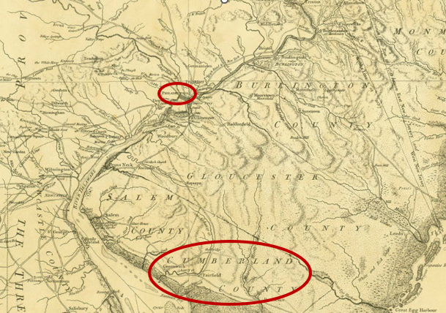
Figure 1.1 The Province of New Jersey Divided into East and West commonly called The Jersey's, 1777

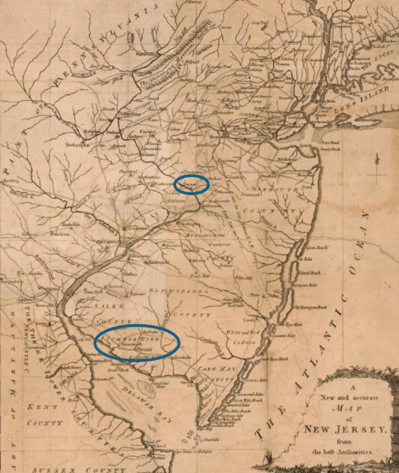
Figure 1.2 A new and accurate map of New Jersey, from the best authorities
Not long after the Revolutionary War ended and life settled, Eunice encountered her own kind of struggle – the death of Elisha on 23 June 1796. As per the custom of the time, Elisha left Eunice a dower of one-third widow’s share for life plus the profits of the home plantation until the youngest sons were of age and a one-third profit of all lands during her lifetime. No records have been found of Eunice remarrying before her death on 6 November 1822.
The following children were born to Elisha and Eunice (Jenkins) Swinney:
2. i. MARTHA SWINNEY, born 8 July 1773 in New Jersey, and died 19 April 1825 in New Jersey. Martha married JEREMIAH BOND DAVIS on 12 February 1771. Jeremiah, the son of Elnathan and Susanna (Bond) Davis, passed away on 27 December 1799 at the young age of twenty-eight, having been born on 6 June 1771. Jeremiah lived his entire life in Cumberland County, New Jersey. Martha and Jeremiah had two children (a) Ruth S. Davis(1796-1851), and (b) Jeremiah Bond Davis, (1799-1856).
- DAVID SWINNEY, born 30 March 1775 in Cohansey, New Jersey, and died on 28 July 1852 in Manayunk, Pennsylvania. David married CLARISSA AYARS, daughter of Elijah and Ann (Davis) Ayars, on 8 January 1806 in Cumberland County, New Jersey. David was a soldier in the War of 1812 and became a landowner. He left for Manayunk, Pennsylvania about 1831 and turned to mercantile, dealing flour and feed in the state. David and Clarissa had eleven children: (a) Jane Swinney (1806-1807), (b) Maria Jenkins Swinney (1808-1885), (c) Elijah Ayres Swinney (1809 – 1872), (d) Elisha Swinney (1811-1887), (e) Ellen Swinney (1813-1884), (f) Margaret Swinney (1818-1882), (g) Eunice Ann Swinney (1819-1848), (h) Jennie Swinney (1821-1823),(i) Janetta C. Swinney (1824-1859),(j) Ruth C.D. Swinney (1826 – unknown), and (k) Eliza Swinney (1830-1830).
- RACHEL SWINNEY, born in New Jersey in 1780, died 29 April 1803 of a ruptured ectopic pregnancy. Rachel married JOSHUA BARRETT on 25 March 1799 in Cumberland, New Jersey. Buried in the Old Broad Street Presbyterian Church Cemetery in Bridgeton, Cumberland, New Jersey, Rachel likely chose to follow the Presbyterian religion or felt she needed to support her husband in his faith, leaving her Baptist roots. Rachel and Joshua had no children before she died.
- DANIEL JACKSON SWINNEY, born 30 September 1781 in Bridgeton, New Jersey, Daniel married ELIZABETH SEELY in Cumberland, New Jersey on 7 March 1811. Daniel served in the War of 1812 and afterward obtained a land grant. Presumably, this land is what drew him to Ohio. A patent was issued to him on 24 April 1820 and Daniel was first enumerated with his family in this area during the 1830 census. He last appeared with Elizabeth in this town in the 1850 Census. He and his wife both died in 1858, presumably from either cholera or scarlet fever, as both diseases plagued the area and Daniel was exposed regularly as a medical doctor. Three children were born to Daniel and Elizabeth: (a) Andrew Jackson Swinney, (1815 – unknown), (b) Ephraim Seeley Swinney, (1817 – 1898), and (c) Ebenezer Hazzard Swinney, (1819 – unknown).
- JOHN SWINNEY, born 7 February 1784 in Cumberland, New Jersey, died 2 May 1843 in Shiloh, Cumberland, New Jersey. John married (1) TACY AYARS on 3 December 1805 in Cumberland New Jersey. Tacy was the sister of Clarissa Ayars, the wife of John’s brother, David. On 20 July 1812, Tacy passed away in New Jersey. John joined the war efforts shortly thereafter and served honorably in the War of 1812. (2) Sometime after returning from war, the Reverend John Davis married John and RUTH MILLER on 28 January 1822. Ruth died shortly thereafter. John married (3) PHEBE VEAL on 1 March 1825 in Cumberland, New Jersey. The wives and John are buried in Shiloh Seventh Day Baptist Church Cemetery at Shiloh, Cumberland, New Jersey. Records exist for three children born to John and Tacy, but to no other wife: (a) Gilbert A. Swinney (1808-1843), (b) Ethan B. Swinney, (1809-1880), and (c) Rees Ayars Swinney (1811-1873).

───── Second Generation ─────

- MARTHA SWINNEY, daughter of Elisha and Eunice (Jenkins) Swinney, was born 8 July 1773 in Cumberland, New Jersey, and died 19 April 1825 in Cumberland County, New Jersey. Martha married JEREMIAH BOND DAVIS, son of Elnathan and Susanna (Bond) Davis, on 22 September 1793 in New Jersey. Jeremiah was born 6 June 1771 in Cumberland, New Jersey and died 27 December 1799, also in Cumberland, New Jersey. Both Martha and Jeremiah were buried in the Shiloh Seventh Day Baptist Church Cemetery in Shiloh, Cumberland, New Jersey.
Jeremiah and Martha were born during the prelude to the Revolutionary War when riots and mobs were actively engaged against the burdens placed by Britain to challenge the colony’s developing economy. The Stamp Act and additional taxes passed by the English Parliament intensified the ban ordered on colonial paper money. This series of financial confinements increased the pressure from creditors to coerce those indebted to reconcile their obligations. Times were lean and many settlers were enraged. “No taxation without representation!” was a phrase coined and credited by James Otis, a local Boston attorney and politician, and likely echoed the feelings of Jeremiah and Martha.
Jeremiah was active in signing petitions for change and did so in 1793 and 1799 for a plea from freeholders and inhabitants for new roads. There is no way of knowing what changes he would have seen or helped to make if he had not died, intestate, at twenty-eight years old. Martha undoubtedly had a good relationship with her Davis in-laws because she inherited land from her father-in-law three years later, likely the portion her deceased husband would have been given.
Martha raised two children without any records of another marriage. She is recorded in multiple years for having to pay land taxes and was likely able to do so through farming the land and selling excess. On 19 April 1825, Martha died and was buried beside her husband in the cemetery belonging to the Seventh Day Baptist Church in Shiloh, Cumberland, New Jersey.
Martha and Jeremiah were the parents of two children:
- RUTH DAVIS (1796-1851) was born 1 December 1796 in Shiloh, Cumberland, New Jersey. She died a spinster on 23 May 1857 in Philadelphia, Pennsylvania. Ruth was given land in the will of her paternal grandfather, Elnathan Davis. Without having issue, Ruth died intestate at the age of sixty and her property was settled by her nephew, Walter B. Davis. Ruth was buried in the Shiloh Seventh Day Baptist Church Cemetery in Shiloh, Cumberland, New Jersey.
+ 3. ii. JEREMIAH BOND DAVIS (1799-1856), was born 27 March 1799 in Hopewell, Cumberland, New Jersey and died 31 July 1856, also in Hopewell. He married (1) ELIZA Davis on 18 April 1820 in Cumberland County, New Jersey. After her death, he married (2) EUNICE ANN AYARS on 20 November 1838 in Cumberland County, New Jersey.
───── Third Generation ─────

- JEREMIAH BOND DAVIS was born 27 March 1799 in Hopewell, Cumberland, New Jersey, and died 31 July 1856, also in Hopewell. He married (1) ELIZA BIVINS on 18 April 1820 in Cumberland County, New Jersey. After her death, he married (2) EUNICE ANN AYARS on 20 November 1838 in Cumberland County, New Jersey.

Jeremiah was raised by a single mother, likely with help from extended family since they lived on neighboring farms. His father, also Jeremiah Bond Davis, died the day Jeremiah reached the age of 9 months.
Religious conflicts may have persisted into the 19th Century during the time when Jeremiah and both of his wives were children. Many religious organizations bickered over theology and church houses in the early part of the century. Baptists, Quakers, Presbyterians, and a few Methodists were beginning to reside in the Cumberland community. Jeremiah and his family participated in the Sabbatarian church family that ancestors, John Sweeney, Dr. Elijah Bowen, John Jarman, Reverend Jonathan Davis, Caleb Ayres, and others established in 1736. This new religious organization was founded the year before Jeremiah’s first wife, Eliza, passed away and many of her relatives are included in the founding group. Many of these men were also relatives of Jeremiah’s second wife, Eunice. The tenets of this religion are believed to have been the same as the typical Calvinistic Baptists, except for their observance of the Sabbath.
Eliza’s death in 1837 left Jeremiah with six young children. Though he did not remarry immediately, he was wed to a cousin of Eliza’s, Eunice Ann Ayars, on 20 November 1838 in Cumberland County, New Jersey. This must have been a busy time in Jeremiah’s life since he was serving a five-year appointment as Hopewell’s Town Clerk and Freeholder.
Eunice must also have been a remarkable woman to have walked into her cousin’s household and helped her husband with six children. Adding three more girls to the mix would have been a challenging task, but one that the family accepted. Evidently, the children treasured one another and considered themselves equal in blood and love, for names were repeated, honoring half-siblings with names for their own children. Truly, this was a conscious effort to blend family.
On 30 July 1856, Jeremiah died intestate, and his son Walter B. Davis and wife, Eunice, served as administrators. Jeremiah was buried at the Shiloh Seventh Day Baptist Church Cemetery in Shiloh, Cumberland, New Jersey.
As a witness to the War of 1812 and the Civil War, Eunice would have seen many young men leave for battle and never return. Though her own stepsons and grandsons lack records of service, Eunice had a son-in-law, Charles Dickinson, who served honorably in the Civil War.
Eunice lived the remainder of her life without a spouse and died on 29 December 1904. She was buried next to her husband in the Shiloh Seventh Day Baptist Church Cemetery.
Children of Jeremiah Bond Davis and his first wife, Eliza Davis:
- MARIETTA DAVIS was born 18 February 1821 in Hopewell, Cumberland, New Jersey and died 25 August 1845 in Shiloh, Cumberland, New Jersey. She married HOWELL WATSON RANDOLPH on 6 October 1842 in Cumberland, New Jersey. Marietta and Howell were the parents of one child: (a) Caroline “Carrie” Fitz Randolph Davis (1844-1910).
- CAROLINE DAVIS was born on 6 September 1823 in Hopewell, Cumberland, New Jersey, and died on 29 March 1842 in New Jersey.
- MARTHA JANE DAVIS was born on 13 September 1826 in Hopewell, Cumberland, New Jersey, and died on 28 August 1896 in Shiloh, Cumberland, New Jersey. Martha married ELLIS A. DAVIS on 28 September 1846 at Trenton, Mercer, New Jersey. Martha and Ellis were the parents of six children: (a) Anna S. Davis (1847-unknown), (b) Ebenezer J. Davis (1850-1872), (c) Elbert Morton Davis (1858-1859), (d) Fannie Eliza Davis (1860 – 1943), (e) Mattie W. Davis (1836 – 1925), and (f) Adelle Davis (1868-1876).
- RUTH S. DAVIS was born on 4 April 1829 in Deerfield, Cumberland, New Jersey, and died on 1 September 1892 in Shiloh, Cumberland, New Jersey. Ruth married WILLIAM A. HUMMEL on 13 March 1853 in Cumberland, New Jersey. Ruth and Williams were the parents of two children: (a) Marietta Hummel (1858-1886), and (b) Wilbert Lincoln Hummel (1861-1933).
- WALTER BOND DAVIS was born on 19 October 1831 in Hopewell, Cumberland, New Jersey, and died on 1 August 1862 in New Jersey. Walter married HARRIET NEWELL ELWELL on 23 January 1856 in Salem, New Jersey. They were the parents of one child: (a) Harmon Elwell Davis (1861- unknown).
- ANN ELIZA DAVIS was born on 18 July 1835 in Hopewell, Cumberland, New Jersey, and died before her sixth birthday in Cumberland County, New Jersey on 7 April 1841.
Children of Jeremiah Bond Davis and his second wife, Eunice Ann Ayars:
- ANNA MARIA DAVIS was born on 27 June 1841 in Hopewell, Cumberland, New Jersey, and died on 6 January 1918 in Shiloh, Cumberland, New Jersey. Anna married HIRAM DAVIS, a farmer, on 29 January 1868 in Shiloh, Cumberland, New Jersey. Three children were born to Anna and Hiram: (a) Florence Anna Davis (1870-1888), (b) Herbert Howard Davis (1872-1874), and (c) Carrie Edna Davis (1877-1935).
- ELIZA SHEPHERD/SHEPPARD DAVIS was born on 25 August 1843 in Deerfield, Cumberland, New Jersey, and died on 27 July 1930 in Shiloh, Cumberland, New Jersey. Eliza married THEODORE FRELINGHUSEN DAVIS, a farmer turned mercantile owner, on 20 February 1867 in Cumberland, New Jersey. Eliza and Theodore were the parents of five children: (a) Isadora J. Davis (1867-1950), (b) Sarah Davis (1867- unknown), (c) Irene Davis (1871-1873), (d) Walter Bond Davis II (1873-1957), and (e) Everett Ayars Davis (1888-1888).
- EMILY AYARS DAVIS was born on May 1847 in Cumberland County, New Jersey, and died in 1928 in New Jersey. Emily married CHARLES B. DICKENSON on 1 April 1873 in Cumberland County, New Jersey. Emily and Charles were the parents of five children: (a) Anna Dickinson (1874-1904), (b) Edward Dickinson (1875-1958), (c) Alfred Dickinson (1877-1945),
(d) Clarence David Dickinson (1885-1950), and (e) Charles W. Dickinson Jr. (1885-1978).

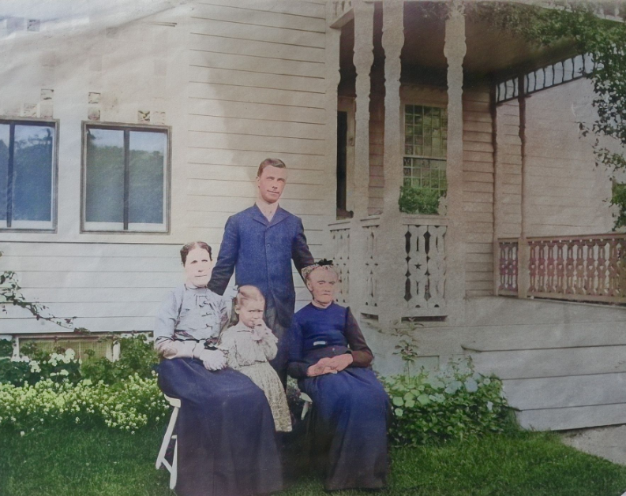
4 Generations of Davises: (Sitting Left) Eliza Shepperd (Davis) Davis [4th generation, 2nd daughter]; (Sitting Right) Eunice Ann (Ayars) Davis [3rd generation, 2nd wife], (Standing in back) Walter Bond Davis II [5th generation, child of Eliza from 4th Generation]; (Standing in center) Miriam Eliza Davis [6th generation, child of Walter Bond Davis II]

Diagram of (Client) linking back to Elisha and Eunice (Jenkins) Swinney (1st Generation):
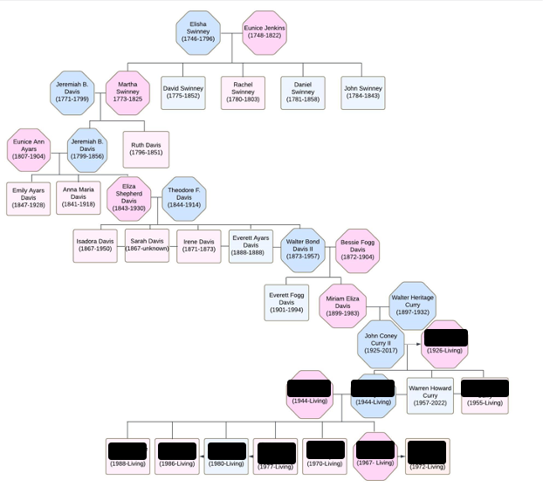

Bibliography
Ancestry. "Public Member Trees." Autumn 2024.
Ashcroft, John R. “Land Records: 1777-1969. Records obtained from the Bureau of Land Management. https://s1.sos.mo.gov.
Cope, Gilbert. FamilyRecord: containing the Settlement and Genealogy to the Present Time, of the Sharples Family, in North America. Philadelphia: Dando Printing and Publishing Co., 1816.
Craig, H. Stanley. Cumberland County New Jersey Genealogical Data: Records Pertaining to Persons Residing in Cumberland County Prior to 1800. Merchantville : H. Stanley Craig, 1872.
Elmer, Lucius Q.C. History of the Early Settlement of Progress of Cumberland County, New Jersey. Bridgeton: George F. Nixon, Publishing, 1869.
FamilySearch. “FamilySearch Family Tree.” Autumn 2024.
FindaGrave. “World’s largest gravesite collection.” Autumn 2024.
Fold3. “Civil War Records.” Autumn 2024. www.fold3.com.
Fold3. “U.S. War of 1812 Service Record Index, 1812-1815.” Autumn 2024. www.fold3.com.
Gallaher, Grace C. “The Jenkins Family of Cape May County, New Jersey.” The Cape May County Magazine V, no. 9 (June 1963): 372.
GenealogyBank. “Died.” West Jersey Pioneer (Bridgeton, NJ), 6 June 1857. https://www.genealogybank.com.
GenealogyBank. “Hopewell.” West Jersey Pioneer (Bridgeton, NJ), 26 Mar 1853. https://www.genealogybank.com.
GenealogyBank. “Married.” Washington Whig (Bridgeton, NJ), 18 February 1822. https://www.genealogybank.com.
Honeyman, Van Doren. “Calendar of Wills, Administrations, Etc., 1751-1760.” Documents Relating to the Colonial History of the State of New Jersey. Vol. 32. Archives of the State of New Jersey, 1924.
Lundin, Leonard. Cockpit of the Revolution: the war for independence in New Jersey. Princeton: Princeton University Press, 1940.
Mulford, William C. Historical Tales of Cumberland County, New Jersey. Bridgeton : The Evening News Company, 1941.
A new and accurate map of New Jersey, from the best authorities. London : n.p., 1780. https://www.loc.gov/item/97683600/.
The Province of New Jersey Divided into East and West commonly called The Jersey's, 1777. London: William Faden Publishing, 1777. https://www.loc.gov/item/74692203.
Treman, Ebenezer Mack. The history of the Treman, Tremaine, Truman family in America, with the related families of Mack, Dey, Board and Ayers. Ithaca: Press of the Ithaca Democrat, 1901.
Samuelson, Richard A. “The Constitutional Sanity of James Otis: Resistance Leader and Loyal Subject.” The Review of Politics 61, no. 3 (Summer 1999): 517.

“FindAGrave,” database, FindAGrave (www.findagrave.com : accessed 12 September 2024), entry for Elisha Swinney, memorial #169704385 ; Gilbert Cope, Family Record: containing the Settlement and Genealogy to the Present Time, of the Sharples Family, in North America, (Philadelphia : Dando Printing and Publishing Co. 1816), p. 540.
“New Jersey, U.S., Compiled Marriage Records, 1684-1886,” database, Ancestry (www.ancestry.com : accessed 12 September 2024), entry for Elisha Swinney and Eunice Jenkins.
Grace C. Gallaher, “The Jenkins Family of Cape May County, New Jersey,” The Cape May County Magazine V, no. 9 (June 1963): 372, accessed in person 16 November 2024, The Church of Jesus Christ of Latter-day Saints Family History Library, Salt Lake City, Utah.
“FindaGrave,” database, FindaGrave (www.findagrave.com : accessed 12 September 2024), entry for Eunice Swinney, memorial #169704422.
Ibid; FindAGrave, memorial #169704385.
https://www.loc.gov/item/01007740/, p. 129-130. Historical Collections, State of New Jersey (Published 1846).
A. Van Doren Honeyman, (ed.), “Calendar of Wills, Administrations, Etc., 1751-1760,” Documents Relating to the Colonial History of the State of New Jersey, (Trenton, NJ: Archives of the State of New Jersey), 1924, Vol. 32, 176, entry for Rev. Nathaniel Jenkins; “New Jersey, U.S. Abstract of Wills, 1670-1817,” database with image, Ancestry (www.ancestry.com : accessed 20 September 2024), entry for John Swinney, Volume 37, p. 316, Abstracts of Wills 1751-1760.
Ibid.
Honeyman, “Calendar of Wills, Administrations, etc., 1751-1760” ; Charles E. Sheppard, “Cohansey Baptist Church: A history of the Cohansey Baptist Church in Old West Jersey,” http://baptisthistoryhomepage.com/cohansey.nj.html.
“FamilySearch Family Tree,” database, FamilySearch (www.familysearch.org : accessed 27 November 2024), entry for: Robert Ayars, ID #L2JS-FZX, John Sweeney, ID#GJJ5-R3Y, Nathaniel Jenkins, #KHM3-RG9, John Sharples, #LV9D-RB7, Richard Bowen, #LZNQ-KTB.
Ibid.
The Province of New Jersey Divided into East and West commonly called The Jersey's, 1777, (London: William Faden Publishing, 1777), accessed 27 November 2024, https://www.loc.gov/item/74692203.
Leonard Lundin, Cockpit of the Revolution: the war for independence in New Jersey, (Princeton: Princeton University Press, 1940), accessed in person 16 November 2024, Family History Library, Salt Lake City, Utah, Catalog ID 974,9 H2Lu.
A new and accurate map of New Jersey, from the best authorities, (London : n.p., 1780), accessed 27 November 2024, https://www.loc.gov/item/97683600/.
“FindaGrave,” memorial #169704385.
“New Jersey, U.S., Abstract of Wills, 1670-1817,” database with image, Ancestry (www.ancestry.com : accessed 12 September 2024), entry for Elisha Swinney, 10 August 1796, p. 359.
“FindaGrave,” memorial #169704422.
“North America, Family Histories, 1500-2000,” database with image, Ancestry (www.ancestry.com : accessed 12 September 2024), entry for Jeremiah Davis (1771-1799) marriage to Martha Swinney (1773-1825) on 22 September 1793; N.A., N.E., North America, Family Histories, 1500-2000, Sharples-Sharpless Family: Vol. 1, p. 41 : Gallaher, Cape May Magazine for birth date and location : “FindAGrave,” memorial #178443374.
“New Jersey, Marriages, 1670-1980,” database, FamilySearch (www.familysearch.org : accessed 20 September 2024), entry for Eunice Jenkins and Elisha Swinney; Hopewell, Cumberland, NJ, British Colonial America, 12 Feb 1771; roll 13.
“FindAGrave,” database, FindAGrave (www.findagrave.com : accessed 17 September 2024), entry for Jeremiah Bond Davis, memorial #178443342.
All vital records come from Cumberland, New Jersey.
“International Genealogical Index (IGI),” database, FamilySearch (www.familysearch.org : accessed 19 September 2024), citing FHL microfilm 457935 : “New Jersey, U.S., Wills and Probate Records, 1739-1991,” database with image, Ancestry (www.ancestry.com : accessed 20 September 2024), entry for Ruth Davis, 7 July 1857; Cumberland Administration Books, Vol A-B, 1818-1911, p. 307; “FindAGrave,” database, FindAGrave (www.findagrave.com : accessed 11 September 2024), entry for Jeremiah Bond Davis, memorial #178406282.
Gilbert Cope, Family Record: containing the Settlement and Genealogy to the Present Time, of the Sharples Family, in North America, (Philadelphia : Dando Printing and Publishing Co. 1816), p. 540.
“New Jersey, County Marriages, 1682-1956,” database with images, FamilySearch (www.familysearch.org : accessed 12 September 2024), Cumberland County Clerk Records, 1806; entry for David Swiney and Clarissa Ayars, 8 January 1806.
“U.S., War of 1812 Service Record Index, 1812-1815,” database, Fold3 (www.fold3.com : accessed 12 November 2024), Entry for David Swinney, Record Group 94, Catalog ID 654501.
H. Stanley Craig, Cumberland County New Jersey Genealogical Data: Records Pertaining to Persons Residing in Cumberland County Prior to 1800, (Merchantville : H. Stanley Craig, 1872), p. 165.
“FamilySearch Family Tree,” database, FamilySearch (www.familysearch.org : accessed 6 September), entry for David Swinney, ID # KH75-MDB.
“FindaGrave,” database, FindaGrave (www.findagrave.com : accessed 12 September 2024), entry for Rachel Swinney Barrett, memorial #169299038.
“New Jersey, U.S., Marriage Records, 1670-1965,” database, Ancestry (www.ancestry.com : accessed 12 September 2024), entry for Rachel Swinney and Joshua Barret, 25 March 1799, Cumberland, New Jersey.
“FindaGrave,” memorial #169299038.
“FindaGrave,” database, FindaGrave (www.findagrave.com : accessed 12 September 2024), entry for Daniel J. Swinney, memorial #154822645 : “Greens and Browns Collection: PA Parish Records,” database with images, FamilySearch (www.familysearch.org : accessed 12 September 2024) : “Marriages, 1806-1853,” Pastor’s notes from Rev. Horatio Gates Jones, D.D., p. 3; entry for Dr. Daniel Swinney and Elizabeth Seeley, both of Cumberland, New Jersey, 7 March 1811.
“U.S., War of 1812 Service Record Index, 1812-1815,” database, Fold3 (www.fold3.com : accessed 12 November 2024), entry for Daniel Swinney, record group 94, catalog ID 654501 : “U.S., War of 1812 Military Bounty Land Warrants, 1815-1858,” database, Fold3 (www.fold3.com : accessed 12 November 2024), entry for Daniel Swinney, record group .94, catalog ID 4923870.
1830 U.S. Census of Mansfield, Richland, Ohio, population schedule, p. 20, digital image, Ancestry (www.ancestry.com : accessed 12 September 2024).
Bureau of Land Management - Daniel J Sweeney – 24 April 1820; 40 acres; Twp 058N- 012W Rng; 5th PM Meridian : 1850 U.S. Census of Madison Township, Richland, Ohio, population schedule, p.130, digital image, FamilySearch (www.familysearch.org : accessed 12 September 2024).
“FindaGrave,” memorial #154822645 : Kevin Martinez, MD, “The Worst Disease Outbreaks in History,” https://www.healthline.com/health/worst-disease-outbreaks-history : 1850 U.S. Census of Madison Township, Richland, Ohio, population schedule, p.130, digital image, FamilySearch (www.familysearch.org : accessed 12 September 2024).
“FamilySearch Family Tree,” database, FamilySearch (www.familysearch.org : accessed 6 September), entry for Daniel Jackson Swinney, ID #LRCB-B9Q.
“FindaGrave,” database, FindaGrave (www.findagrave.com : accessed 12 September 2024), entry for John Swinney, memorial #179084569.
Cope, The Sharples Family, p. 540 ; “FindaGrave,” memorial #179084569.
Craig, Cumberland County Genealogical Data, p. 165.
Ibid.
“U.S., War of 1812 Service Record Index, 1812-1815,” database, Fold3 (www.fold3.com : accessed 18 September 2024), Entry for John Swinney, Roll #M602_0203.
“Married,” Washington Whig (Bridgeton, New Jersey), 18 February 1822, Vol II, Issue 60; digital image, GenealogyBank (www.genealogybank.com : accessed 20 September 2024).
Cope, The Sharples Family, p. 540.
Ibid ; “FindaGrave,” database, FindaGrave (www.findagrave.com : accessed 12 September 2024), entry for Phebe Swinney, memorial #179084569.
“FindaGrave,” memorial #179084569.
Gallaher, June 1963, Vol V, Number 9 : “FindAGrave,” memorial #178443374.
“North America, Family Histories, 1500-2000,” database with image, Ancestry (www.ancestry.com : accessed 12 September 2024), entry for Jeremiah Davis (1771-1799) marriage to Martha Swinney (1773-1825) on 22 September 1793; Cope, The Sharpless Family, p. 41 : “FindAGrave,” memorial #178443342.
“North America, Family Histories, 1500-2000” ; “FindAGrave,” memorial #178443342.
“FindaGrave,” memorial #179084569; “FindAGrave,” memorial #178443342.
Richard A. Samuelson, “The Constitutional Sanity of James Otis: Resistance Leader and Loyal Subject,” The Review of Politics 61, no. 3 (Summer 1999), 517.
“U.S., Census Reconstructed Records, 1660-1820,” database, Ancestry (www.ancestry.com : accessed 12 September 2024), Cumberland County, New Jersey, Road Records 1752-1904, New Jersey State Archives, Box 1, p. 3; entry for Jeremiah Davis : “U.S., Census Reconstructed Records, 1660-1820,” database, Ancestry (www.ancestry.com : accessed 12 September 2024), Cumberland County, New Jersey, Road Records 1752-1904, New Jersey State Archives, Box 1, p. 2; entry for Jeremiah Davis.
“FindAGrave,” memorial #178443342.
“New Jersey, U.S., Wills and Probate Records, 1739-1991,” database with image, Ancestry (www.ancestry.com : accessed 20 September 2024), entry for Martha Davis, 8 December 1802; wills, Vol. 40, 1802-1804, p. 366-367.
“New Jersey, U.S., Compiled Census and Census Substitutes Index, 1643-1890,” database, Ancestry (www.ancestry.com : accessed 12 September 2024); entry for Martha Davis, NJ Early Census Index database, Cumberland County, Hopewell Township, p. 8, 1807; Ibid, p. 2, 1800; Ibid, p. 5, 1802; Ibid, p. 3 1803; Ibid, p. 8, 1810.
“FindaGrave,” memorial #178443374.
“FindAGrave,” database, FindAGrave (www.findagrave.com : accessed 19 September 2024), entry for Ruth S. Davis, memorial #178406853.
“Died,” West-Jersey Pioneer, (Bridgeton, New Jersey), 6 June 1857, p. 3, column 3; digital image, GenealogyBank (www.genealogybank.com : accessed 19 September 2024).
“New Jersey, U.S., Wills and Probate Records, 1739-1991,” database with image, Ancestry (www.ancestry.com : accessed 20 September 2024), entry for Ruth Davis, 8 December 1802; wills, Vol. 40, 1802-1804, p. 366-367.
“New Jersey, U.S., Wills and Probate Records, 1739-1991,” database with image, Ancestry (www.ancestry.com : accessed 20 September 2024), entry for Ruth Davis, 7 July 1857; Cumberland Administration Books, Vol A-B, 1818-1911, p. 307.
“FindaGrave,” memorial #178406853.
“FindAGrave,” memorial #178406282.
“New Jersey, County Marriages, 1682-1956,” database with images, FamilySearch (www.familysearch.org : accessed 12 September 2024), Record of Marriages, Cumberland County, p. 340; entry for Jeremiah Davis and Eliza Davis, 18 April 1820.
“New Jersey, County Marriages, 1682-1956,” database with images, FamilySearch (www.familysearch.org : accessed 11 September 2024), Record of Marriages Cumberland County, p. 17; entry for Eunice Ann Ayars and Jeremiah B. Davis, 20 Nov. 1838.
“FindAGrave,” memorial #178406282.
“New Jersey, County Marriages, 1682-1956,” database with images, FamilySearch (www.familysearch.org : accessed 12 September 2024), Record of Marriages, Cumberland County, p. 340; entry for Jeremiah Davis and Eliza Davis, 18 April 1820.
“New Jersey, County Marriages, 1682-1956,” database with images, FamilySearch (www.familysearch.org : accessed 12 September 2024), Record of Marriages, Cumberland County, p. 17; entry for Jeremiah Davis and Eunice Ann Ayars, p. 17.
“New Jersey, U.S., Wills and Probate Records, 1739-1991,” database with image, Ancestry (www.ancestry.com : accessed 20 September 2024), entry for Jeremiah Davis, 8 December 1802; wills, Vol. 40, 1802-1804, p. 366-367.
“FindaGrave,” memorial #178443342.
Lucius Q.C. Elmer, History of the Early Settlement and Progress of Cumberland County, New Jersey, (Bridgeton: George F. Nixon, Publishing, 1869), p. 92-96.
Ibid., p. 51-62.
Ibid., p. 94.
“FindAGrave,” database, FindAGrave (www.findagrave.com : accessed 11 September 2024), entry for Eliza Ayars Davis, memorial #178406319.
Ebenezer Mack Treman and Murray E. Poole, History of the Treman, Tremaine, Turman Families in America, with the related families of Mack, Dey, Board, and Ayers (New York : Press of the Ithaca Democrat, 1901), 1554.
“New Jersey, County Marriages, 1682-1956,” p. 17; entry for Eunice Ann Ayars and Jeremiah B. Davis, 20 Nov. 1838.
“Hopewell,” West Jersey Pioneer (Bridgeton, NJ), 26 Mar 1853, p. 3, column 2 ; digital image GenealogyBank (www.genealogybank.com : accessed 27 November 2024).
Jeremiah and Eunice’s children: 3.ii Eliza Shepherd Davis named her son after her half brother, Walter Bond Davis from her father’s first marriage. Even Eliza’s given name was the name of Jeremiah’s first wife, Eliza Ayars Davis. Additionally, Jeremiah and Eunice gave to their third daughter, Emily, the middle name of Ayars, the maiden name of Jeremiah’s first wife.
“New Jersey, U.S. Wills and Probate Records, 1739-1991,” database with image, Ancestry (www.ancestry.com : accessed 11 September 2024), Administration Books, Cumberland, Vol A-B, 1818-1911; entry for Jeremiah B. Davis on 11 August 1856.
“FindAGrave,” memorial #178406282.
“U.S., Civil War Draft Registrations Records, 1863-1865,” database with image, Ancestry (www.ancestry.com : accessed 16 September 2024), entry for Charles B. Dickinson, Cumberland, vol. 2 of 3; 9 July 1863.
“FindAGrave,” database, FindAGrave (www.findagrave.com : accessed 11 September 2024), entry for Eunice Ann Ayars Davis, memorial #178406425.
Ibid.
“FindAGrave,” database, FindAGrave (www.findagrave.com : accessed 11 September 2024), entry for Marietta Davis, memorial #178502574.
Ibid.
“FamilySearch Family Tree,” database, FamilySearch (www.familysearch.org : accessed 17 November 2024), entry for Caroline Fitz Randolph, ID #2DXL-TH2.
“FamilySearch Family Tree,” database, FamilySearch (www.familysearch.org : accessed 17 November 2024), entry for Caroline Davis, ID #K4GH-8QW.
“FamilySearch Family Tree,” database, FamilySearch (www.familysearch.org : accessed 17 November 2024), entry for Martha Jane Davis, ID #K6S3-X9S.
“New Jersey Marriages, 1678-1985,” database, FamilySearch (www.familysearch.org: accessed 20 November 2024), entry for Ellis J. Davis and Martha J. Davis, 28 Sept 1846, Trenton, Mercer, NJ.
“FamilySearch Family Tree,” database, FamilySearch (www.familysearch.org : accessed 20 November 2024), entry for Anna S. Davis, ID #93J7-WRX.
“FamilySearch Family Tree,” database, FamilySearch (www.familysearch.org : accessed 20 November 2024), entry for Ebenezer J. Davis, ID #93J7-WR1.
“FamilySearch Family Tree,” database, FamilySearch (www.familysearch.org : accessed 20 November 2024), entry for Elbert Morton Davis, ID #93J7-WR1.
“FamilySearch Family Tree,” database, FamilySearch (www.familysearch.org : accessed 20 November 2024), entry for Fannie Eliza Davis, ID #LRZ8-5G7.
“FamilySearch Family Tree,” database, FamilySearch (www.familysearch.org : accessed 20 November 2024), entry for Mattie W. Davis, ID #93J7-WBM.
“FamilySearch Family Tree,” database, FamilySearch (www.familysearch.org : accessed 20 November 2024), entry for Adelle Davis, ID #K41P-KST.
“FamilySearch Family Tree,” database, FamilySearch (www.familysearch.org : accessed 20 November 2024), entry for Marietta Hummel, ID #M5VY-GJL.
“FamilySearch Family Tree,” database, FamilySearch (www.familysearch.org : accessed 20 November 2024), entry for Wilbert Lincoln Davis, ID #M5VB-82S.
“FamilySearch Family Tree,” database, FamilySearch (www.familysearch.org : accessed 20 November 2024), entry for Harmon Elwell Davis, ID #K48S-Q8B.
“FindAGrave,” database, FindAGrave (www.findagrave.com : accessed 11 September 2024), entry for Eliza Ayars Davis, memorial #178406319.
“FindAGrave,” database, FindAGrave (www.findagrave.com : accessed 11 September 2024), entry for Anna Maria Davis Davis, memorial #178460582.
Cope, The Sharpless Family Book, p. 1026.
“FamilySearch Family Tree,” database, FamilySearch (www.familysearch.org : accessed 17 November 2024), entry for Florence Anna Davis, ID #M5VY-4GL.
“FamilySearch Family Tree,” database, FamilySearch (www.familysearch.org : accessed 17 November 2024), entry for Herbert Howard Davis, ID #M5VY-33T.
“FamilySearch Family Tree,” database, FamilySearch (www.familysearch.org : accessed 17 November 2024), entry for Carrie Edna Davis, ID #9VLN-TFM.
“FindAGrave,” database, FindAGrave (www.findagrave.com : accessed 11 September 2024), entry for Eliza Shepherd Davis, memorial #178458594.
Cope, The Sharpless Family Book, imaged, p. 1041.
“FamilySearch Family Tree,” database, FamilySearch (www.familysearch.org : accessed 20 November 2024), entry for Isadora J. Davis, ID #KZWC-N2W.
“FamilySearch Family Tree,” database, FamilySearch (www.familysearch.org : accessed 20 November 2024), entry for Sarah Davis, ID #MBW5-HSZ.
“FamilySearch Family Tree,” database, FamilySearch (www.familysearch.org : accessed 20 November 2024), entry for Irene Davis, ID #KC62-R5Q.
“FamilySearch Family Tree,” database, FamilySearch (www.familysearch.org : accessed 20 November 2024), entry for Walter Bond Davis II, ID #L76M-9V8.
“FamilySearch Family Tree,” database, FamilySearch (www.familysearch.org : accessed 20 November 2024), entry for Everett Ayars Davis, ID #MVN3-K2R.
“FindAGrave,” database, FindAGrave (www.findagrave.com : accessed 11 September 2024), entry for Emily Ayars Davis Dickinson, memorial #22631982.
“Marriage records, Cumberland County: Cumberland. Vital Records,” database with image, FamilySearch (www.familysearch.org : accessed 13 September 2024), loose paper image with handwritten note referencing marriage between Charles B. Dickenson and Emily A. Davis.
“FamilySearch Family Tree,” database, FamilySearch (www.familysearch.org : accessed 20 November 2024), entry for Anna Dickinson, ID #K4V7-HCJ.
“FamilySearch Family Tree,” database, FamilySearch (www.familysearch.org : accessed 20 November 2024), entry for Edward Dickinson, ID #MRSD-MJS.
“FamilySearch Family Tree,” database, FamilySearch (www.familysearch.org : accessed 20 November 2024), entry for Alfred Dickinson, ID #MRS6-14Z.
“FamilySearch Family Tree,” database, FamilySearch (www.familysearch.org : accessed 20 November 2024), entry for Clarence David Dickinson, ID #LZ5Y-NMK.
“FamilySearch Family Tree,” database, FamilySearch (www.familysearch.org : accessed 20 November 2024), entry for Charles W. Dickinson, Jr., ID #MRS6-VRV.

