Lionel Hakes Johnson: Proving Parental Relationship Through DNA

April 17, 2026

By: Debi
Heritage Chasers

Table of Contents
Research Objective 3
Construction of DNA Inheritance 3
DNA Explained 3
DNA Networks 4
DNA Match Prudence 5
DNA Methodology 5
1. Group and Label DNA Matches to Divide the Network 5
2. Identify the Closest Known and Best-Known Matches 5
3. Expand the Genetic Network 5
4. Divide the Genetic Network 5
5. Determine the Generation of Connection for Unknown Matches 5
6. Build Quick Trees 6
Starting Point for this Project 7
Methodology for this Project 7
Evidence 8
Documentary Evidence for this Project 8
1. (Living ), 2c1r to Tester (No Tree provided by Living) 9
2. (Living), 3c to Tester (37 people on the tree, not on shared line) 9
3. (Living), 3c to Tester (Small Tree on Living’s account) 10
DNA Evidence for this Project 10
Using Autosomal DNA to Prove the Biological Relationship of Lionel “Olie” Hakes Johnson to His Parents 11
Exclusion of Specific Sibling Lines from Objective 12
JOHNSONS/HOLMANS (Paternal Line of Olie Hakes Johnson) – 12
HAKES/MORSES (Maternal Line of Olie Hakes Johnson) - 13
Analysis and Correlation 14
Conclusion 14
Suggestions for Further Research 14

Research Objective
The objective of this project was to prove the biological relationship of one of the tester’s great-grandparents to their parents. Lionel “Olie” Hakes Johnson was the selected great-grandparent, the paternal grandfather to the tester’s mother. His parents, Benjamin Julius and Harriet Jane (Hakes) Johnson were the target ancestry couple. The following pedigree chart shows the tester’s mother, (Living), and her lineage, with Lionel “Olie” Hakes Johnson marked with a blue rectangle (Figure 1). The parents of this grandfather are marked in yellow and are the couple from which all DNA matches in this study should descend.
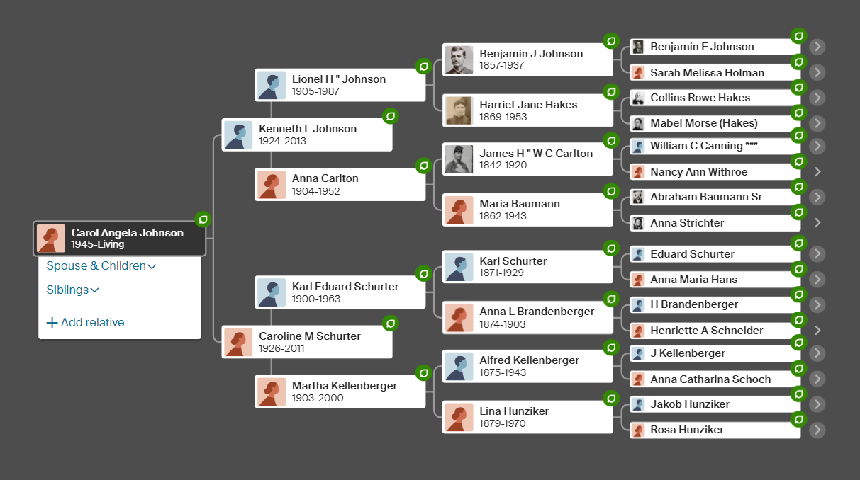
Figure 1. Lineage of (Living Client) with research objectives marked.

Construction of DNA Inheritance

DNA Explained
Each person is composed of multiple types of DNA structures, including mitochondria DNA, X-DNA, Y-DNA (for men), and autosomal DNA. Autosomal DNA tests, like the ones used at MyHeritage, AncestryDNA, 23andMe, and FamilyTreeDNA, examine the DNA code contained inside each cell. This DNA encryption is received as an inheritance, with each parent donating approximately 50% to an offspring’s genetic makeup. However, the amount of autosomal DNA derived from distant relatives is randomly mixed, a process known as recombination. The result of recombination means that the autosomal DNA extending from each ancestor is diluted with each succeeding generation.
Furthermore, recombination of DNA means that not every person will inherit 25% of DNA from each grandparent, nor that they will get 12.5% from each great grandparent. Not all third cousins will share autosomal DNA with you despite the shared genealogical pedigree. DNA that is shared with an ancestor is measured in units called CentiMorgans (cM), which measures the genetic distance between two ancestors. The more cM shared with a DNA match, the stronger the evidence for a close genetic relationship between two people.
The following chart (Figure 2) titled, the “Shared cM Project,” exhibits collective cM ranges and averages shared between various relationships.
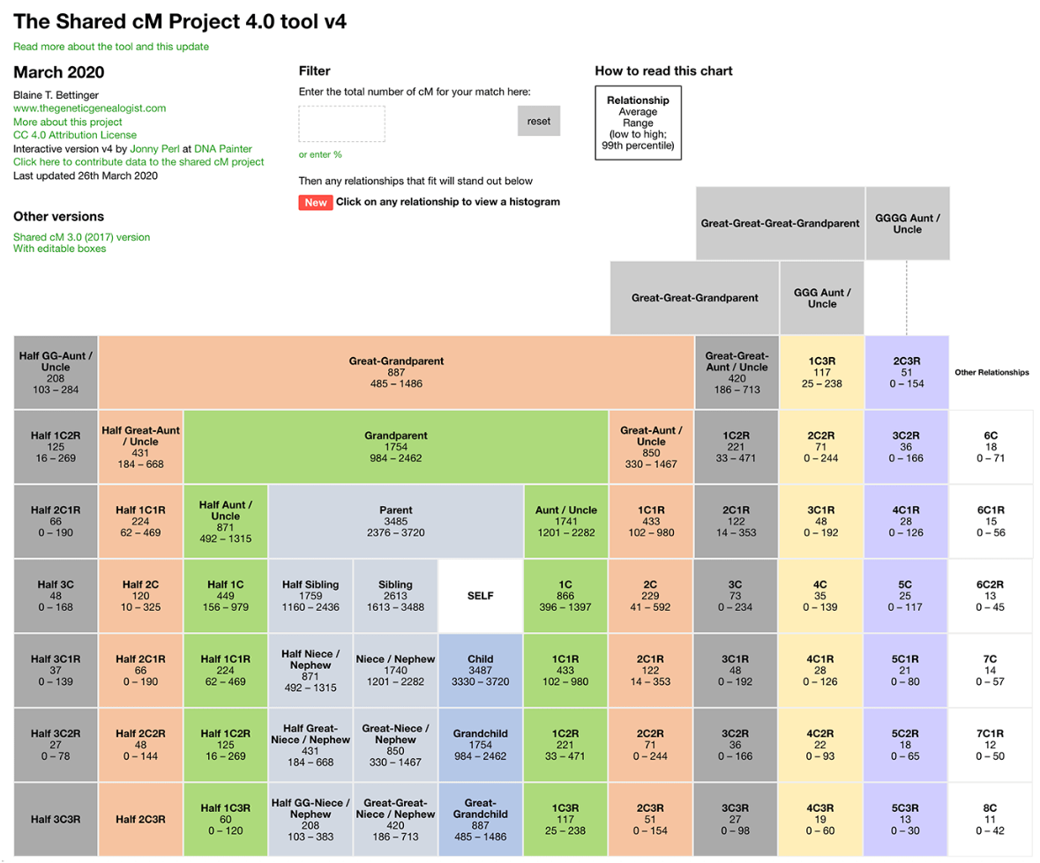
Figure 2. The Shared cM Project indicating amount of cM shared for known relationships.

DNA Networks
Autosomal DNA matches identified by ancestral genomics companies are generated when a significant number of matching chromosomal segments are found. These shared clusters of people formulate a shared group, also termed a genetic network. Each match within the genetic network shares a Most Recent Common Couple (MRCC), the most recent couple from which all matches in the network are descended. As the shared group increases in size, particularly as the group members trace their lineage through multiple different offsprings of the MRCC, the evidence of descent from the MRCC becomes stronger. This creates compelling scientific evidence to show that the MRCC is indeed the genetic network’s common ancestor. However, genetic relationships require genealogical documentation for confirmation because of the fluctuating cM ranges for each likely relationship.

DNA Match Prudence
If matches are not full siblings and are only related on one genetic path, they contain DNA that is not shared with one another. The farther distant a relationship is, the more DNA each contains that is not shared. Due to recombination and additional DNA being given to each match from unrelated partners, segments of matched DNA become smaller. (See Figure 2.)
Because genetic networks cannot tell us exact relationships between distantly related individuals, inaccurate or incomplete family trees lead to erroneous assumptions. Thus, it is necessary to use verified genealogical documentation in conjunction with DNA research. To work towards this goal of accurate family trees, the genetic genealogy community builds “quick research trees.” These trees are rapidly constructed using a minimum number of verified records to link matches from one generation to the next until reaching the MRCC. Genealogical documentation is even more necessary to overcome DNA constraints for matches using inaccurate family trees or showing small segment (15 cM or less) matches, as they have a high rate of false matches despite being frequently employed by genomic companies.

DNA Methodology
Several sequential steps are taken to pursue proof of genetic relationship. The following guidelines were followed for the objective of this project.

Group and Label DNA Matches to Divide the Network
To pursue a genealogical research objective, isolating matches who are related to one another and the MRCC is necessary. From the list of matches, first cousins are used to divide the network between paternal and maternal grandparent matches. Second cousins divide the network between each of the great-grandparent matches and third cousins divide the network between the 2nd great grandparent matches, and so forth.

Identify the Closest Known and Best-Known Matches
The best way to gather hints for matches in the target genetic network is to identify the closest known matches and to look for documents that will help establish correct relationships. From this list, one must verify the correct cousin relationship exists for the target generation. The best-known matches will share the most cM with the fewest DNA segments.

Expand the Genetic Network
The genetic network needs to be expanded “wide and deep,” using the cousins in the targeted group as a guide. If possible, add all known children, grandchildren, and great-grandchildren to the Target Ancestral Couple

Divide the Genetic Network
Next, the MRCC’s child’s DNA is divided from their spouse. Depending on the generation targeted, the cousin level will be selected that will reflect the different DNA. To separate the DNA of a great-grandparent, second cousins will divide the network along the paternal and maternal lines, third cousins will divide the DNA of 2nd great-grandparents, etc.

Determine the Generation of Connection for Unknown Matches
After dividing the genetic network, the appropriate match cousin group and the cM range desired are selected (see Figure 2). Using the match’s small tree and the approximate birth year of the match, determine if this match is likely the same generation or a removed generation. Enter the shared cM in a database located at DNAPainter.com (See Figure 3.) to determine the likelihood of a particular relationship (See Example 1). Next, determine the approximate location of an ancestor of the match close to the probable MRCC to research. It may be necessary to expand to another generation or two.

Build Quick Trees
Quick Trees are made to rapidly establish a genealogical connection back to the MRCC for people who do not have published trees or who have no trees. Though these trees are unverified, they are necessary to proceed in proving the genetic match. Therefore, once matches are selected for proof, full documentation must be performed. The generation of connection activity for unknown matches assists in building trees.

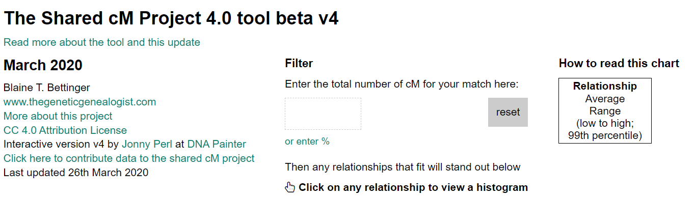
Figure 3. Enter the number of cM for the match.
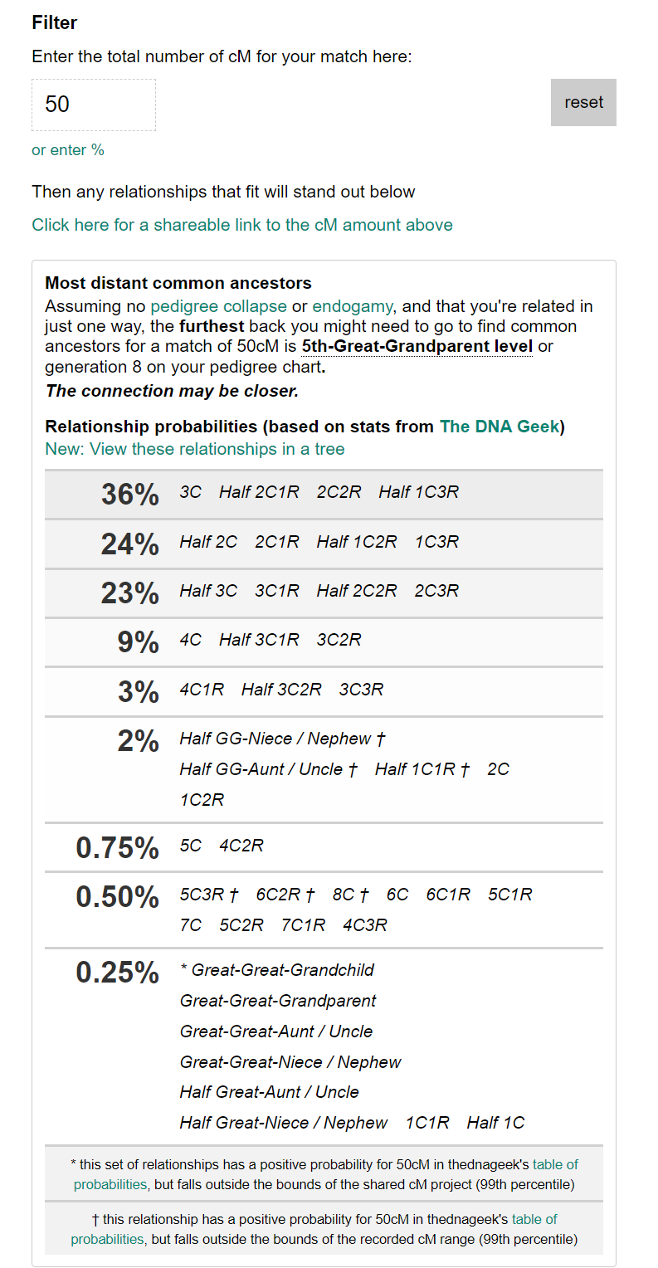
Example 1. Example results for a “50 cM” match

Starting Point for this Project
Lionel “Olie” Hakes Johnson has been well documented. As this project began, it was known that he was the 12th child of 16 children born to his mother, Harriet “Jane” Hakes, and his polygamous father, Benjamin Julius Johnson. Olie and his wife, Anna Carlton, had four children, including a set of twins. Olie’s children and their families are also well researched and documented. Olie and Anna’s oldest child was named Kenneth. (Living) was Kenneth’s first child.
In FamilySearch and Ancestry, Olie’s siblings are not correctly detailed, nor are his sibling’s children and grandchildren. Though family stories include lore about various 2nd granduncles and aunts, few accounts have been recorded. There is a descendant book published by the B.F. Johnson Family, Arizona Branch, but it is focused on Olie’s grandfather, Benjamin Franklin Johnson, and his polygamous wives. Though this book lists Olie and his siblings, it does not provide concrete documentation for the listed individuals and conflicts with other published records. It also does not contain descendants born after 1980 due to the year of publication.
The detailed evidence from FamilySearch and Ancestry for Olie’s family includes vital information, including births, marriages, deaths, and burials, for each of Olie’s children, their spouses, as well as their children and their children’s spouses. Many of Olie’s siblings, born closer to the year he was born, are also well researched, with many of their children and grandchildren correctly noted.
The concern for this objective is the lack of documentary evidence for Olie’s older siblings. Though it is acknowledged that Olie’s father practiced polygamy, his other wives’ children are eliminated from this project.

Methodology for this Project
To begin this project, (the tester) took an AncestryDNA test to obtain autosomal DNA results. The test results also provided extended family matches with shared segments and cM length information.
The next step was to identify and isolate matches according to the tester’s maternal and paternal cousins. Since the objective of this project was to prove the parental relationship of a maternal great-grandfather, dividing the network at the second cousin level was necessary. Colors were randomly assigned to each of the testers’ eight great-grandparents, and five to ten matches were selected for each of these divisions.
Next, cousins were identified for the Olie and Anna Johnson group. This was done by looking for the best matches. These contained both known or easily found genealogical documentation as well as the largest number of shared cM on the fewest number of segments.
Using Ancestry’s DNA Match Comparison page for the Target Ancestral couple (the parents of Olie Johnson, Benjamin Julius, and Harriet Jane Hakes Johnson), the network was expanded by using the “Shared Matches” application. This new list of people formed a triangulation between the tester, the comparison match, and the newly discovered matches, all showing the same DNA marker on identical segments. This genetic network was marked, and the process was repeated with additional people marked on the DNA Match Comparison Page.
The network was again divided by 4th cousins to separate the DNA coming from the Target Ancestral Couple’s siblings. Once this was done, the generation of connection was estimated, and the best 3rd cousin candidates were selected based on cM length and number of shared segments with the tester. According to the Shared cM Project Chart (Figure 2), the average number of cM searched lies in the range of 0-234 but averages at 73 cM.
Each selected 3rd cousin was viewed for genealogical information and if none was found or little information was available, a Quick Tree was made for each. This Quick Tree was documented to tie them to their parents and to include proof of previous generations back to the Target Ancestral Couple, Benjamin Julius and Harriet Jane (Hakes) Johnson. The documented evidence along with the DNA proof for these three cousins and the tester yielded evidence to create a LucidTree (See Figure 4). Each generation from the tester to the target MRCC was substantiated by at least two genealogical documents.

Evidence
Genealogical study aims to achieve valid inferences about ancestors. This is performed with proper evaluation of documents. The credited resources and evidence yields dependable conclusions. Additionally, DNA testing results examine precise locations of a person’s genome to reveal exact markers and indicate biological relationships through shared genetic material.

Documentary Evidence for this Project
Documentary evidence for all selected matches links back to the target couple, Benjamin Julius Johnson and Harriet Jane Hakes. The linking DNA test is shown in upper case letters and the person from whom the DNA material passed within each generation is in capitalization below. Living Client – Tester
Parents – Living and LIVING,
Grandparents – KENNETH L. JOHNSON and Caroline Martha Schurter,
Great-Grandparents – LIONEL H., “Olie” JOHNSON and Anna Carlton,
Target 2nd Great Grandparents – BENJAMIN JULIUS JOHNSON and HARRIET JANE HAKES,

Living Cousin to Tester, 2c1r to Tester (No Tree provided by Garry)
Parents – LIVING and Living,
Grandparents – JULIUS RUSSELL and Rosalie Wood JOHNSON,
Target Great-Grandparents – BENJAMIN JULIUS JOHNSON and HARRIET JANE HAKES,

Living Cousin to Tester, 3c to Tester (37 people on the tree, not on shared line)
Parents – LIVING and Living,
Grandparents – LIVING and Ernest Carlyle Turley,
Great-Grandparents – LIVING and Living,
Target 2nd Great Grandparents – BENJAMIN JULIUS JOHNSON and HARRIET JANE HAKES,

Cousin to Tester, 3c to Tester (Small Tree on Jacob’s account)
Parents – LIVING and Living,
Grandparents – LIVING and Reece Fielding Jarvis,
Great-Grandparents – CASSA MAY JOHNSON and William Stark Lazear,
Target 2nd Great Grandparents – BENJAMIN JULIUS JOHNSON and HARRIET JANE HAKES,

DNA Evidence for this Project
AncestryDNA returned over 8,000 matches for the tester’s targeted maternal line and was eventually narrowed to a potential group of over 5,000 people. Following the methodology outlined for this project, the following three cousin matches were selected and are shown along with the cM length and number of segments shared with the Tester:

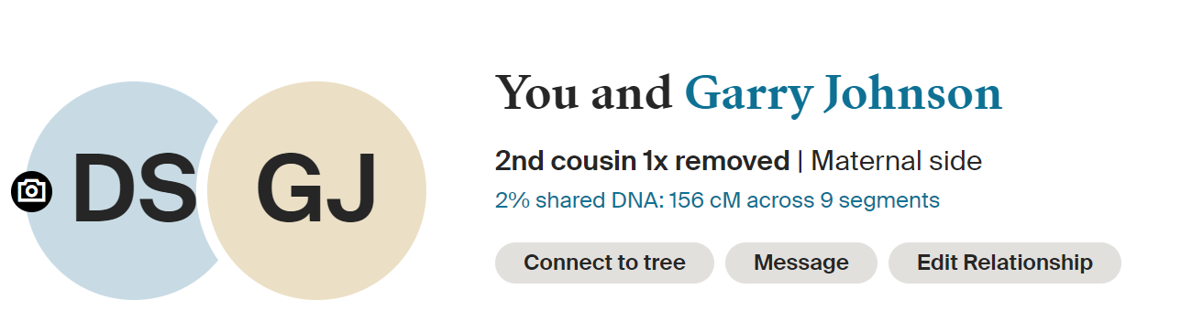



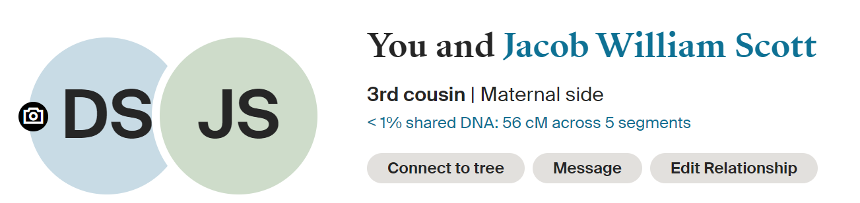

Using Autosomal DNA to Prove the Biological Relationship of Lionel “Olie” Hakes Johnson to His Parents
A Lucidchart was completed once documentation of the Tester’s matches was finished, allowing proper placement of each match in the Lucidchart below (See Figure 4). The three siblings of Olie Johnson are each an ancestor to each of the Tester’s matches.
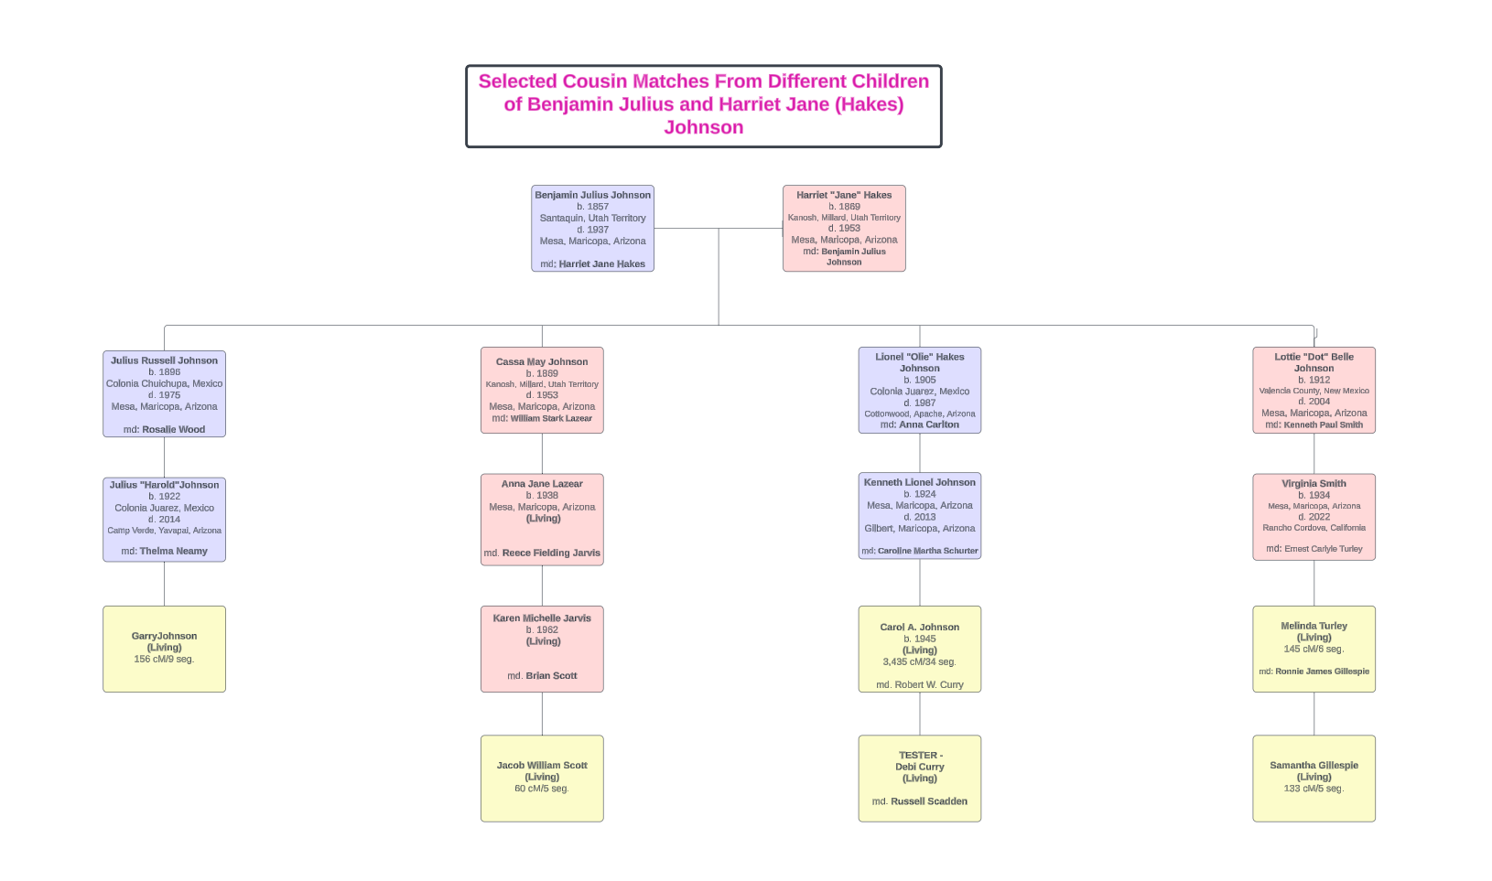
Figure 4. Lucidchart showing final DNA Pedigree for Tester and cousins

Exclusion of Specific Sibling Lines from Objective
Research into Olie’s siblings uncovered double relationships for the parents of both Benjamin Julius Johnson and Harriet Jane (Hakes) Johnson, where a person was related to someone else on more than one genetic line. This potentially brings DNA from both lines and cannot be isolated to a specific source. Therefore, the following people’s descendants were eliminated from being a potential match for this project. These lines, detailed below, were excluded from the objective and are thus not listed in Figure 4.

JOHNSONS/HOLMANS (Paternal Line of Olie Hakes Johnson) –
This branch of the Tester’s family is heavily composed of Johnsons, LeBarons, and Holmans. They intermarried second cousins and uncles/aunts frequently. Identifying eight cousins with bloodlines untainted with additional DNA inherited from other places besides the 3rd great grandparents, Benjamin Franklin Johnson (BFJ) and Sarah Melissa Holman Johnson, was challenging.
Sarah Melissa, Harriet Naomi, and Susan Adeline Holman were the daughters of James Sawyer Holman and Naomi Roxanna LeBaron. The mother of Benjamin Julius Johnson, Sarah Melissa, was the fifth polygamous wife, joining two of her sisters and her ½ aunt from the LeBaron side, Melissa Bloomfield LeBaron, in marrying BFJ. He had additional wives who bore children and required examination of their marriage partner’s pedigrees.
I only used cousin matches descending from Sarah and BFJ for this project. The descendants of Melissa, Harriet, and Susan could not be used. Adding to the complexity of the gene pool is the fact that three of Sarah’s children required DNA match elimination to prevent the double cousin effect of additionally mixed LeBaron chromosomes. Once the descendants of the three related wives were eliminated, all other descendants of BFJ are listed below. Notation is made regarding their potential DNA match acceptance or elimination, with an explanation as follows:
- Other wives of BFJ and their children:
- Mary Ann Hale
  - Joseph Ezekiel – Acceptable (married a “Grant” lacking the surname concerns)
  - Benjamin Samuel – Acceptable (married a daughter of BFJ’s brother, Joel Hills, without surname concerns in the branches of Joel’s wife)
  - Mary Ann – Acceptable (married a “Park” lacking branch surname concerns)
  - Vilate Elizabeth – Eliminated (married Don Moroni LeBaron, nephew of Melissa Bloomfield LeBaron, BFJ’s first wife)
- Sarah Jane Spooner
  - Sarah Jane – Eliminated (Sarah married Benjamin LeBaron, son of David Tully LeBaron and Esther Melita Johnson. David was Melissa Bloomfield LeBaron’s brother and Esther was BFJ’s sister.)
  - Julia Ann – Eliminated (Julia married Don Moroni LeBaron Sr.)
- Flora Clarinda
  - Clarinda Huetta – Acceptable (married a “Winget” without surname concerns on his branches)
- Eliza Perkins Dean Saunders - No children were born to this union.

- Children from BFJ and Sarah Melissa Holman Johnson:
- Benjamin Julius (target gg grandfather) – Acceptable with some exclusions (Benjamin Julius had two wives bearing children, Isabella Russell and Harriet Jane Hakes (target gg grandmother). Many of Isabella’s children’s descendants helped populate Colorado City, an area known for polygamy. Descendants from Isabella have proven laborious to screen and therefore eliminated from chosen matches.
- Brigham Moroni – Acceptable (married Jannetta Isabella Hawley, daughter of Charles and Ann Jane Russell Hawley)
- Heber Franklin – Acceptable (married Sarah Elizabeth Senior, daughter of Joseph and Ellen Hodgson Senior)
- Sariah Agnes – Unacceptable (married David Alma Steves, son of Walter and Abigail Elizabeth Holman Stevens – Sariah’s mother-in-law was the niece of her maternal grandmother.)
- John Angus – Acceptable (married Maude August Burns, parents unknown, from Alabama)
- Sarah Melissa – Unacceptable (married Talmai Emerson Pomeroy, son of Francis and Sarah Colburn Pomeroy; This relation crosses into the Hakes/Morse family with one of their sons, Daniel Edgar, marrying the niece of Francis Pomeroy.)
- Cassandra – Unacceptable (married Heber Chase Kimball Pomeroy, son of Francis and Jessamine Routledge Pomeroy; This relation crosses into the Hakes/Morse family with one of their sons, Daniel Edgar, marrying the niece of Francis Pomeroy.)
- Lionel Brand – Acceptable (married Elnora Hill, daughter of William Hill from Scotland and Emma Meacham from Iowa)
- Ellis Hills – Acceptable (married Adeline Sirrine, daughter of Warren and Serretta Daley Sirrine)
- Delightra “Victoria” – Acceptable (married William Boyd Passey, son of William G. and Asenath Wilcox Passey)
- George Albert – Acceptable (married Esmerelda Bruton, unknown parents)

HAKES/MORSES (Maternal Line of Olie Hakes Johnson) -
Unlike the Johnson/Holman/LeBarons, the Hakes and Morse lines did not usually intermarry with a particular family. The exception to this was the target gg grandmother, Harriet Jane Hakes, who married Benjamin Julius Johnson; her brother, Daniel Edgar Hakes, married Minnie Johnson, the half-sister of Benjamin Julius Johnson whose mother was Melissa LeBaron Johnson. To avoid a double-cousin effect, I eliminated Daniel’s descendants from the matches selected. An additional elimination was made to Collins Riley Hakes because his wife, Emma, was the cousin to the husbands of two of the Johnson girls in this generation.
Father: Collins Rowe Hakes (Son of Weeder Vander Hakes and Eliza Amanda Beebe)
Mother: Mabel Ann Morse (Daughter of Justus Morse and Elizabeth Towne)

Children: 1. Ann Eliza (md. Lyman Leavitt, son of John and Lucy Rowell Leavitt)
2. Sarah Melissa (md. James Charlesworth, son of Thomas and Alice Barrow Charlesworth)
3. Lottie Mable (md. Louis Lamb, son of Joseph Smith and Harriet Cornelia Clawson Lamb)
4. Harriet “Jane” (md. Benjamin Julius Johnson – son of BFJ and Sarah Melissa Holman Johnson) –Target 2nd great grandmother
5. Collins Riley (md. Emma Pomeroy, daughter of Elijah and Mary Annetta Coleman Pomeroy; Emma is the first cousin of Talmai Pomeroy who married Sarah Melissa Johnson as well as the first cousin of Heber Pomeroy, who married Cassandra Johnson. Both Sarah Melissa and Cassandra were daughters of BFJ and Sarah Melissa Holman Johnson. Collins Riley Hakes and Emma Pomeroy; Sarah Melissa Johnson and Talmai Pomeroy; and Cassandra Johnson and Heber Pomeroy have descendants that carry 2nd cousin effects.)
6. Daniel Edgar (md. Minnie Johnson – daughter of David Albion Johnson and Melissa LeBaron Johnson. Melissa is the daughter of Benjamin Franklin Johnson. Thus, descendants from Daniel have been eliminated in the pool of matches to avoid double, triple, etc. relationships.)
7. Ruby Amanda (md. Henry McNeil – son of James Reid and Mary Jane Montgomery McNeil)

Analysis and Correlation
Genealogical findings through documentation and scientific testing of DNA prove that Olie’s parents were Benjamin Julius and Harriet Jane (Hakes) Johnson. Each generation of each of the descendants has sources linking them to their parents. Additionally, the shared DNA coming down four different children’s lines provides indisputable proof of parentage and sibling relations.

Conclusion
Researching the autosomal DNA for this client has provided an expansive basis for continued research. Over 5,000 DNA matches and several notes were added to the appropriate DNA groups. There was limited time to explore the Shared Matches. Many of the matches do not reveal maiden last names in this study since seven of the sixteen children born to Benjamin and Harriet Johnson were female. Additionally, many granddaughters have married and born children bearing their husband’s last name. This research session has been successful in proving the objective of parenthood of the tester’s great-grandparent, but could be expanded to prove this relation in each of the siblings to the great-grandparent.

Suggestions for Further Research
- Identify the genealogical data at the 3rd cousin level for each child of Benjamin and Harriet (Hakes) Johnson, obtaining documentation tying cousins back to the targeted couple.
- Email should be sent to each match of the tester lacking a tree or with small trees so that additional information can be documented.
- Continue further DNA testing on pedigrees to verify the trees posted on Ancestry.
- Research and extend the trees of the Holmans, LeBarons, and Hakes to find common ancestors.

Jonny Perl and Blaine T. Bettinger, “The Shared cM Project 4.0 tool v4,” DNA Painter (https://dnapainter.com : accessed 5 April 2024).
“Autosomal DNA match thresholds,” webpage, International Society of Genetic Genealogy (https://isogg.org : accessed 6 April 2024).
Descendants of Benjamin Franklin Johnson, (Mesa : Lofgreen Printing Co., 1980 ).
Jonny Perl and Blaine T. Bettinger, “The Shared cM Project 4.0 tool v4,” DNA Painter (https://dnapainter.com : accessed 5 April 2024).
“Arizona, U.S., County Marriage Records, 1865-1972,” digital image, Ancestry (https://ancestry.com : accessed 11 April 2024), entry for Living.
“U.S., Newspapers.com, Marriage Index, 1800s – Current,” digital image, Ancestry (https://ancestry.com : accessed 11 April 2024), entry for Client.
1950 U.S. Federal Census of Fish Creek, Maricopa, Arizona, ED 7-111; p. none listed; digital image, Ancestry (https://ancestry.com : accessed 11 April 2024), entry for Kenneth L. Johnson Family.
“U.S., Obituary Collection, 1930 – Current,” database, Ancestry (https://ancestry.com : accessed 11 April 2024), entry for [Caroline Martha] Johnson (Schurter).
1930 U.S. Federal Census of Fish Creek, Maricopa, Arizona, ED 7-64; p. 1A; digital image, Ancestry (https://ancestry.com : accessed 11 April 2024), entry for Lionel H. Johnson Family.
“Arizona, U.S., County Marriage Records, 1865-1972,” digital image, Ancestry (https://ancestry.com : accessed 11 April 2024), entry for Kenneth L. Johnson and Caroline M. Schurter, p. 567.
“Arizona, U.S., School Census Records, 1910-1917,” digital image, Ancestry (https://ancestry.com : accessed 11 April 2024), entry for Lionel Johnson.
1920 U.S. Census of Mesa, Arizona, population schedule, ED 29, sheet 5B; digital image, Ancestry (https://ancestry.com : accessed 20 March 2024); entry for Benjamin J. Johnson Family.
1940 U.S. Census of Maricopa, Arizona, population schedule, ED 7-89, sheet 4B; digital image, Ancestry (https://ancestry.com : accessed 20 March 2024); entry for Julius R. Johnson Family.
Mesa Branch of the Benjamin Franklin Johnson Family, Descendants of Benjamin Franklin Johnson, (Mesa : Lofgreen Publishing, July 1980), p. 5-30.
Mesa Branch of the Benjamin Franklin Johnson Family, Descendants of Benjamin Franklin Johnson, (Mesa : Lofgreen Publishing, July 1980), p. 5-30.
Mesa Branch of the Benjamin Franklin Johnson Family, Descendants of Benjamin Franklin Johnson, (Mesa : Lofgreen Publishing, July 1980), p. 5-30.
1920 U.S. Census of Chandler, Maricopa, Arizona, population schedule, ED 29, sheet 5B; digital image, Ancestry (https://ancestry.com : accessed 20 March 2024), entry for Benjamin J. Johnson.
Mesa Branch of the Benjamin Franklin Johnson Family, Descendants of Benjamin Franklin Johnson, (Mesa : Lofgreen Publishing, July 1980), p. 5-30.
“California Birth Index, 1905-1995,” digital record, Ancestry (http://ancestry.com : accessed 20 March 2024); entry for Living Cousin.
“Nevada, U.S., Marriage index, 1956-2005,” digital record, Ancestry (http://ancestry.com : accessed 20 March 2024), entry for Living Cousin, book 784, p.15.
State of California, Death certificate 3202234005470 (2022), Name Protected; Department of Health Services, Sacramento.
State of California, Death certificate 3202234005668 (2022), Name Protected; Department of Health Services, Sacramento.
1940 U.S. Census of Mesa, Arizona, population schedule, ED 7-66, sheet 15B; digital image, Ancestry (https://ancestry.com : accessed 20 March 2024); entry for Name Protected.
“Arizona, U.S., County Marriage Records, 1865-1972,” digital image, Ancestry (http://ancestry.com : accessed 20 March 2024); entry for Names protected.
1920 U.S. Census of Chandler, Maricopa, Arizona, population schedule, ED 29, sheet 5B; digital image, Ancestry (https://ancestry.com : accessed 20 March 2024), entry for Benjamin J. Johnson Family.
Mesa Branch of the Benjamin Franklin Johnson Family, Descendants of Benjamin Franklin Johnson, (Mesa : Lofgreen Publishing, July 1980), p. 5-30.
Edres Bryant Barney, "Name Protected holds many fond memories of childhood in rural Arizona," EA Courier, 18 October 2023, p. 1; digital image, EACourier (https://eacourier.com : accessed 11 April 2024).
Whitepages (www.whitepages.com : accessed 11 April 2024), entry for Living.
Edres Bryant Barney, "Name Protected holds many fond memories of childhood in rural Arizona," EA Courier, 18 October 2023, p. 1; digital image, EACourier (https://eacourier.com : accessed 11 April 2024).
Vining Funeral Home Records (Arizona), "Name Protected: February 26 1934 - November 24, 2018," digital image, Vining Funeral Home (https://viningfuneral home.com : accessed 11 April 2024), published 26 November 2018; citing Name Protected.
“Arizona, U.S. Birth Certificates, 1880-1935,” digital image, Ancestry (https://ancestry.com : accessed 11 April 2024), entry for Living.
1940 U.S. Federal Census for Pine Town, Gila, Arizona, population schedule, ED 4-17B, Sheet 1B; digital image, Ancestry (https://ancestry.com : accessed 11 April 2024); entry for Name Protected.
“Arizona, U.S., School Census Records, 1910-1917,” digital image, Ancestry (https://ancestry.com : accessed 11 April 2024), entry for Name Protected.
1920 U.S. Census of Chandler, Maricopa, Arizona, population schedule, ED 29, sheet 5B; digital image Ancestry (https://ancestry.com : accessed 20 March 2024), entry for Benjamin J. Johnson Family.

