Proof Documents for Flood Line
Compiled by Heritage Chasers, December 2025
Debi
HeritageChasers@gmail.com
Colonial Dames Membership
These documents prove generational relationship.

Living Person Connecting Generations 1 to 2

I presume you have a copy of your birth certificate? This would be placed on this page.

(Merton Reese “Pat” Bowe) Connecting Generations 2 to 3
1940 U.S. Census for Police Jury Ward 6 E of Bayou Bonne Idee, Morehouse, Louisiana, ED 34-14, Page 222, Sheet 3B; digital image, FamilySearch (FamilySearch.org : accessed 17 December 2025).
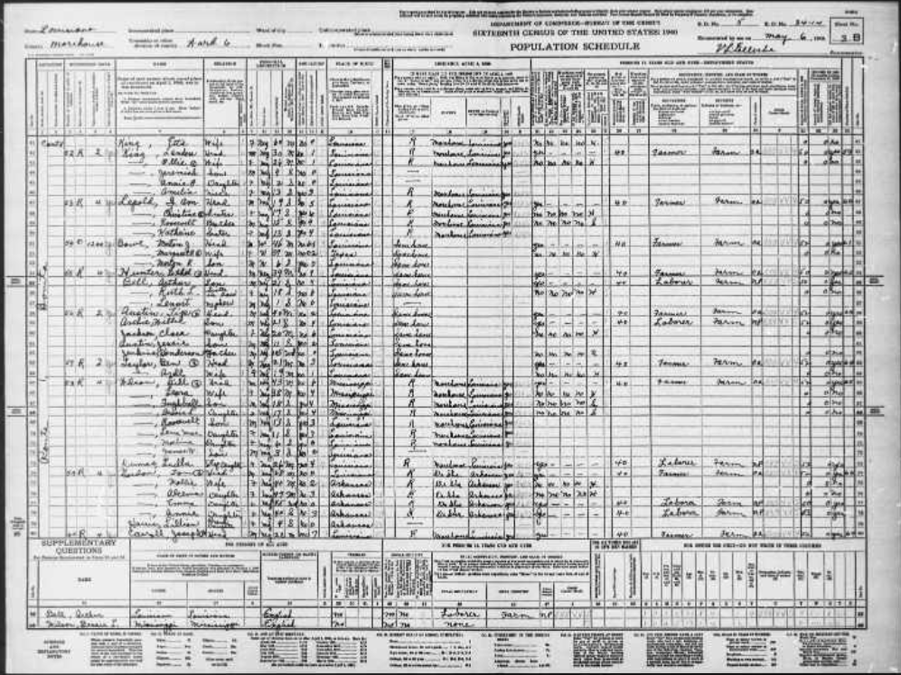
https://www.familysearch.org/ark:/61903/3:1:3QSQ-G9MR-LQ37?view=index&cc=2000219&lang=en&groupId=
- 1940 Census lists Merton R. Bowe (age 6), as son of Merton J. and Margaret R. Bowe. See line 53.
- Obituary dated 16 January 2014 (Bastrop Daily, Enterprise, LA) lists Merton’s parents as Merton John and Margaret Lee Reese Bowe and his daughter, Margaret Faye Bowe Malone.
(Merton Reese “Pat” Bowe) Connecting Generations 2 to 3 (also, 1 to 2)

Do you have a copy of your father’s obituary? That would be placed here.

(Margaret Lee Reese Bowe - Marriage) Marriage, Generation 3
“Arkansas, County Marriages, 1837-1957,” digital image, FamilySearch (FamilySearch.org : accessed 17 December 2025), Film #004307976, image 293; entry for M.J. Bowe and Margaret Rese, 19 May 1928.
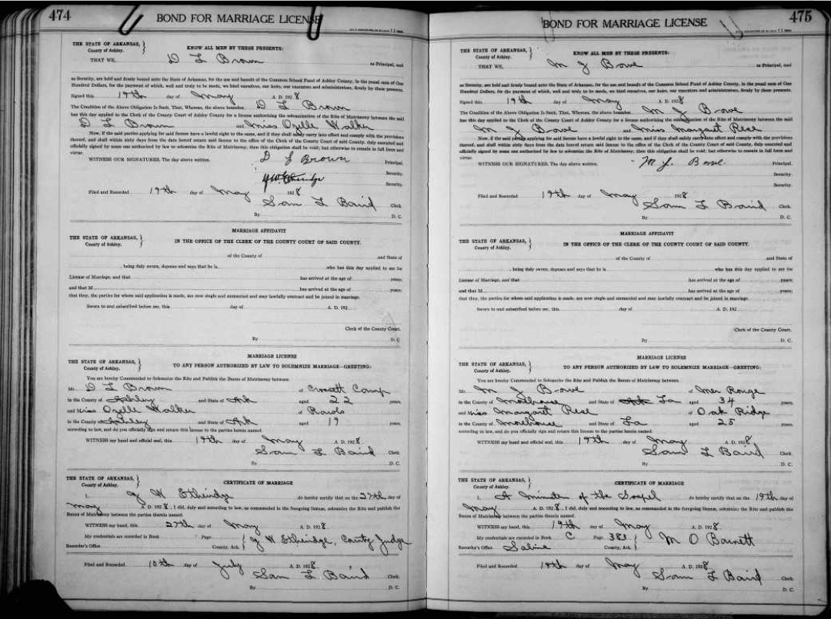
https://www.familysearch.org/ark:/61903/3:1:S3HT-D1MQ-KG9?view=explore&action=view&cc=1417439&lang=en&groupId=M9ZD-NQ8
- Marriage of Margaret Reese to M.J. Bowe
(Margaret Reese Bowe - Parents) Connecting Generations 3 - 4
1910 U.S. Census for Police Jury Ward 5, Morehouse, Louisiana, ED 92, Page 97, Sheet 16A; digital image, FamilySearch (FamilySearch.org : accessed 17 December 2025).
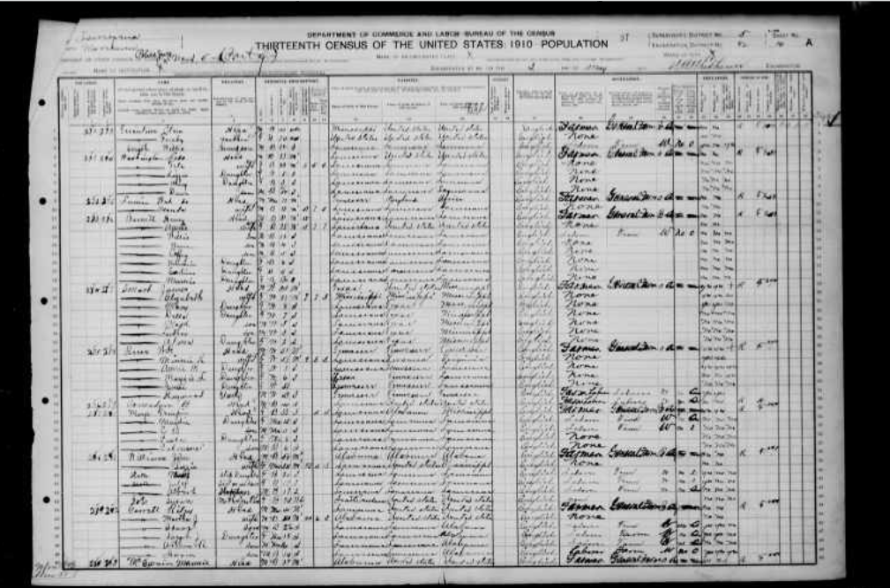
https://www.familysearch.org/ark:/61903/3:1:33S7-9RVJ-665?view=index&personArk=%2Fark%3A%2F61903%2F1%3A1%3AMPYH-XBL&action=view&cc=1727033&lang=en&groupId=
- 1910 Census lists Maggie Reese (6 years old, est. birth year 1904) as daughter of W.H. Reese and Minnie K. Reese. See line 29.

(Margaret Lee Reese Bowe) Connecting Generations 3 - 4
Louisiana Certificate of Death #11667 (1957), Margaret Reese Bowe; Louisiana State Department of Health, Division of Public Health Statistics, Baton Rouge.
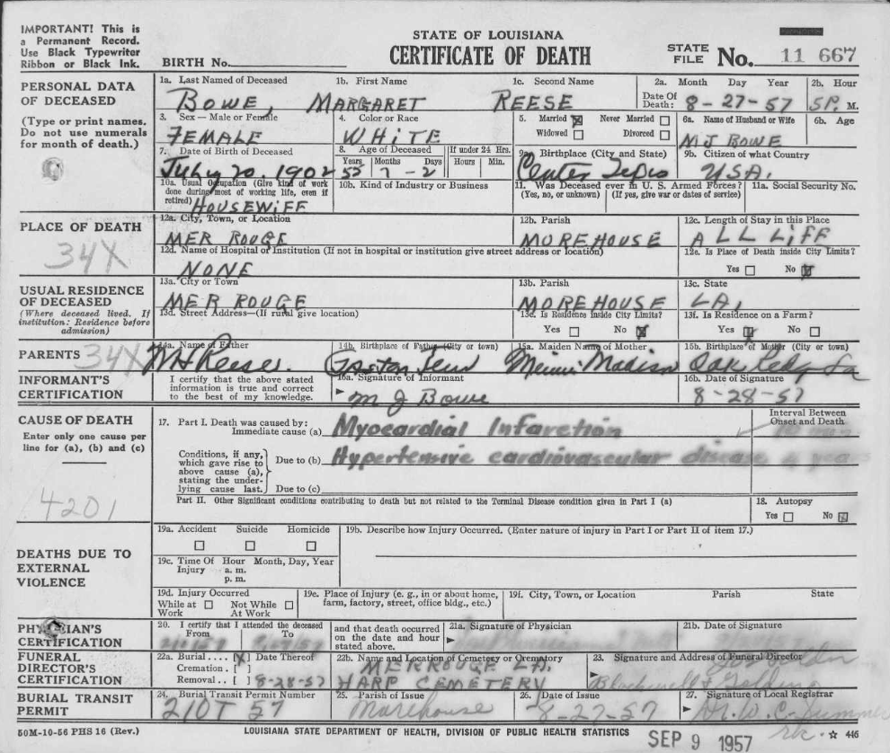
https://www.familysearch.org/ark:/61903/3:1:33SQ-G5QN-9BPC?view=index&personArk=%2Fark%3A%2F61903%2F1%3A1%3AVNRB-JS3&action=view&cc=1609793&lang=en&groupId=
- The death certificate indicates that Margaret was married to M.J. Bowe and that her parents were Minnie Madison and M.J. Reese. She died on 27 August 1957 in Mer Rouge, Morehouse, LA.

(Minnie Madison Reese) Marriage, Generation 4
Louisiana Certificate of Death #10420 (1951), Minnie Madison Reese; Louisiana State Department of Health, Division of Public Health Statistics, Baton Rouge.
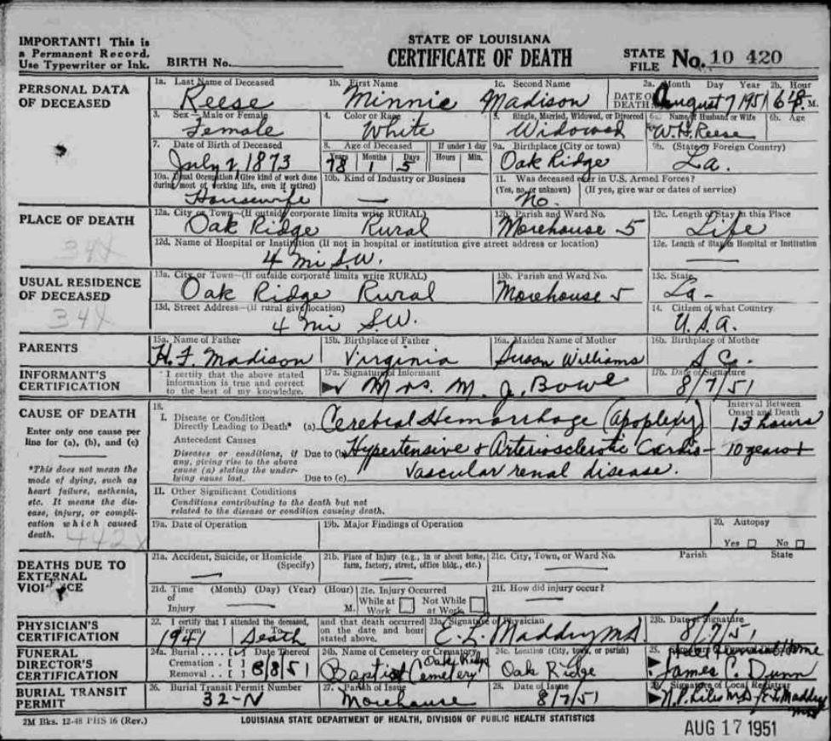
https://www.familysearch.org/ark:/61903/3:1:S3HT-D1HQ-MR9?view=index&personArk=%2Fark%3A%2F61903%2F1%3A1%3AFS1Q-35Y&action=view&cc=1609793&lang=en&groupId=M9S3-2B5
- The death certificate indicates that Minnie was the widow of W.H. Reese and that her parents were Susan Williams and J.F. Madison, both of Virginia. She died on 7 August 1951 in Oak Ridge, Morehouse, LA.
- Also note in the 1910 census (not attached), documentation for Minnie Kate and William Reese indicate they have been married for 9 years.
(Minnie Kate Maidson Reese) Connecting Generations 4 - 5
1900 U.S. Census for Oak Ridge, Morehouse, Louisiana, ED 17, Page 211, Sheet 12A; digital image, FamilySearch (FamilySearch.org : accessed 17 December 2025).
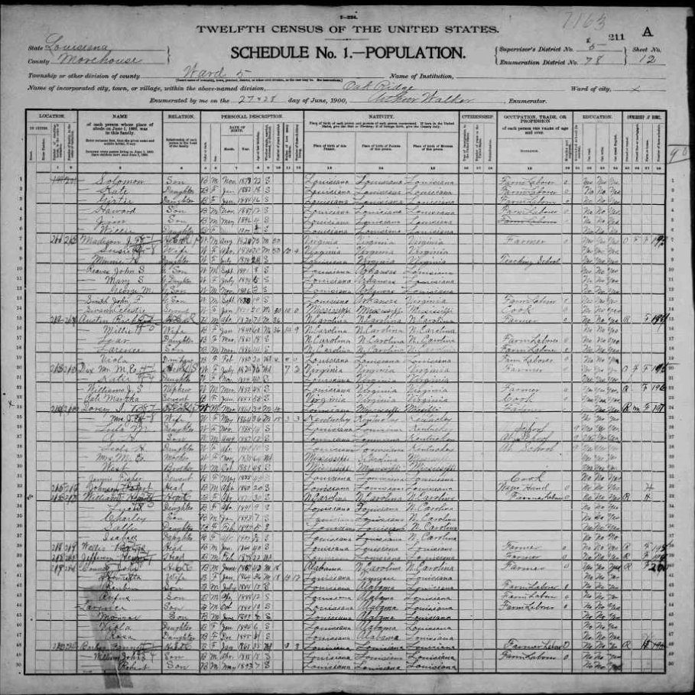
https://www.familysearch.org/ark:/61903/3:1:S3HY-DCFQ-M29?view=index&personArk=%2Fark%3A%2F61903%2F1%3A1%3AMS5D-TR9&action=view&cc=1325221&lang=en&groupId=M9LN-6W5
- This census indicates that Minnie is single at age 25 and teaching school. She lives with her parents, J.F. and Susie C. Madison, both of whom were born in Virginia.

(John Flood Madison) Marriage, Generation 5
“Marriage Bonds, 1767-1862, Pittsylvania County, Virginia,” digital image, FamilySearch (FamilySearch.org : accessed 17 December 2025); entry for John F. Madison and Susan C. Williams, 28 November 1850.
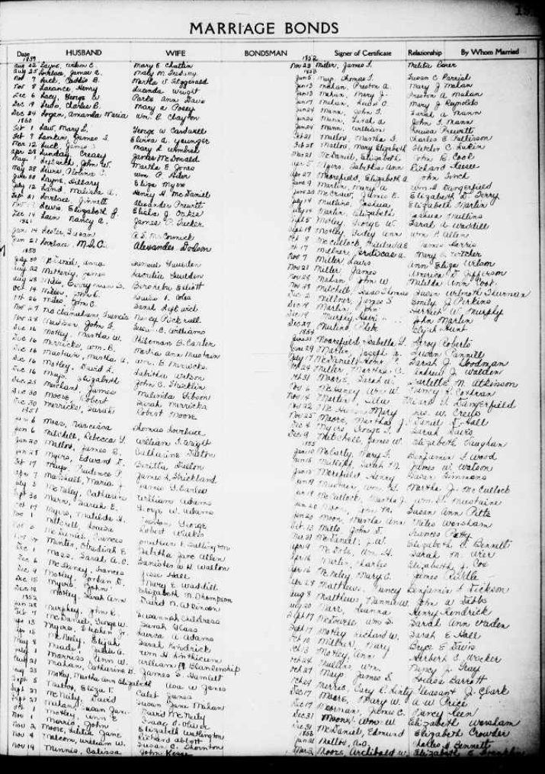
https://www.familysearch.org/ark:/61903/3:1:3QS7-99LX-MH81?view=explore&action=view&cc=4149585&lang=en&groupId=M9JZ-QDY
- Marriage record for John F. Madison and Susan C. Williams, 28 November 1850.
(
(John F. Madison) Extra Document, Generation 5
“US, Civil War Service Records (CMSR) – Confederate – Louisiana, 1861-1865,” digital image, Fold3 (Fold3.com : accessed 17 December 2025), NARA ID #586957; entry for John F. Madison, Scott’s Co., Reserve Corps.
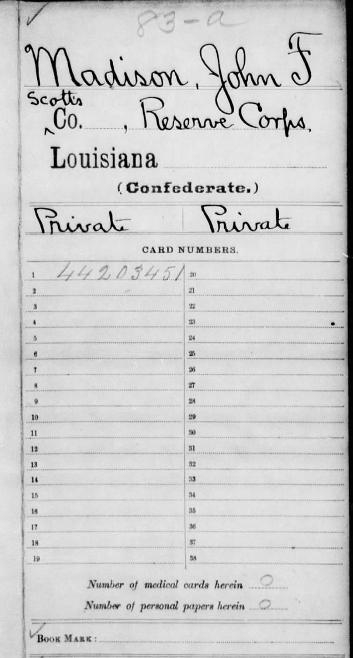
https://www.fold3.com/image/84531336/madison-john-f-page-1-us-civil-war-service-records-cmsr-confederate-louisiana-1861-1865?xid=6794&_gl=1*1t1td7s*_gcl_au*MTkyODE0MjA5LjE3NjYwMzAxNjY.*_ga*ODEzNDU5MTEuMTc2NjAzMDE3MQ..*_ga_4QT8FMEX30*c2JiOTM1OWY2LWY0MDAtNDI4Ni05YWZkLWQyM2RiMDhlZTEwNiRvMSRnMSR0MTc2NjAzMDM5NiRqNDUkbDAkaDA.*_ga_LMK6K2LSJH*c2JiOTM1OWY2LWY0MDAtNDI4Ni05YWZkLWQyM2RiMDhlZTEwNiRvMjkwJGcxJHQxNzY2MDMwMzk3JGo2MCRsMCRoMA..
- Indicates John was part of the Pelican Regiment, Infantry and Pointe Coupee Regiment, Militia and Provisional Regiment, Louisiana Legion and River Sharp Shooters and Reserve Corps, A-Me.

(John F. Madison) Extra Document, Generation 5
“Deed Book 54, 1852-1853, Pittsylvania County, Virginia,” digital image, FamilySearch (FamilySearch.org : accessed 17 December 2025); Film #007646019, image 271; entry for John F. Madison and Susan A. Williams, 28 November 1850.
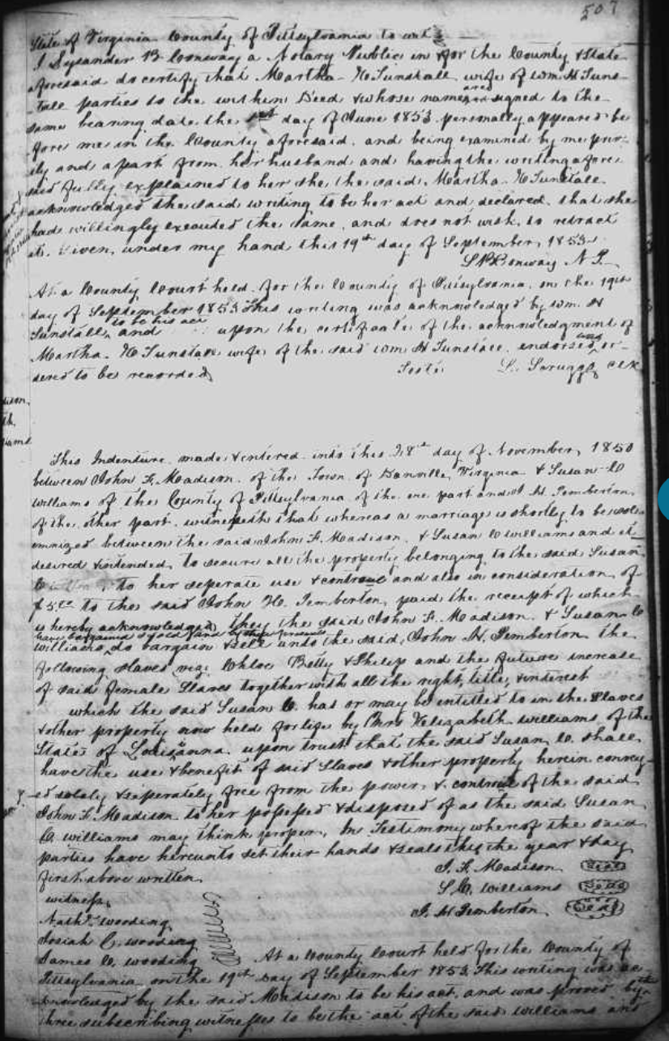
https://www.familysearch.org/ark:/61903/3:1:3Q9M-C9PX-GSHL-C?view=fullText&keywords=Madison%2CJohn%20F%20Madison%2CJohn%20F%2CVirginia&lang=en&groupId=M9JH-GHL
- Settlement of slave property with indication that John F. Madison and Susan A Williams will soon be married.

(John F. Madison) Marriage, Generation 5
“Marriage Bonds, 1770-1799, Pittsylvania County, Virginia,” digital image, FamilySearch (FamilySearch.org : accessed 17 December 2025); Film #007741072, image 366; entry for John F. Madison and Susan C. Williams, 28 November 1850.
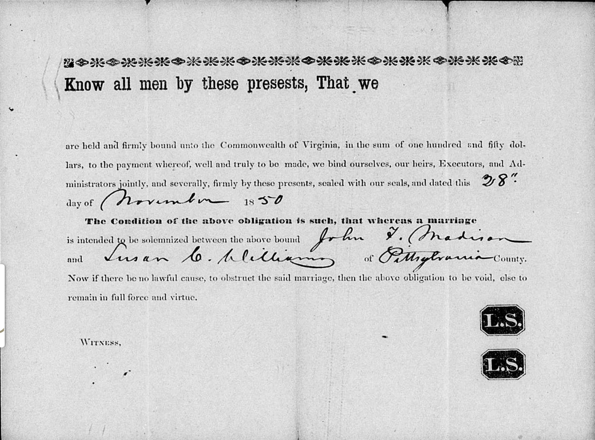
https://www.familysearch.org/ark:/61903/3:1:3Q9M-C91Z-6ZY9?view=fullText&keywords=Madison%2CJohn%20F%2CVirginia&lang=en&groupId=M9MF-5G1
- Indicates that John F. Madison and Susan C. Williams intended to marry.

(Susan C. Williams) Extra Document, Generation 5
“Louisiana, Cemetery Records,” digital image, FamilySearch (FamilySearch.org : accessed 18 December 2025); Film #008139840, image 378; entry for Susan C. Williams.
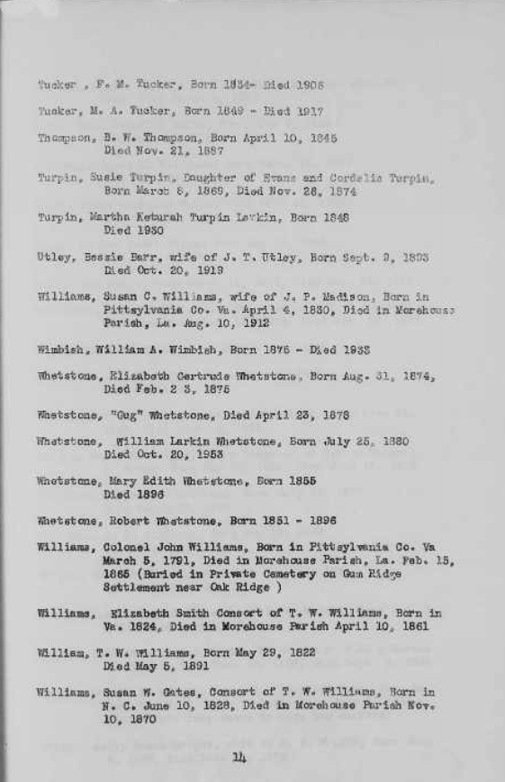
https://www.familysearch.org/ark:/61903/3:1:3Q9M-CSK7-PSMY-Y?view=explore&action=view&cc=3041284&lang=en&groupId=TH-909-71273-53997-51
- “Williams, Susan C. Williams, wife of J.P. Madison, Born in Pittsylvania Co. Va, April 4 1830, Died in Morehouse Parish, LA, Aug. 10, 1912.”
(John Flood Madison) Generation 5-6
1850 U.S. Census of Ward No. Five, Morehouse, Louisiana, population schedule, p. 39; digital image, FamilySearch (FamilySearch.org : accessed 18 December 2025).
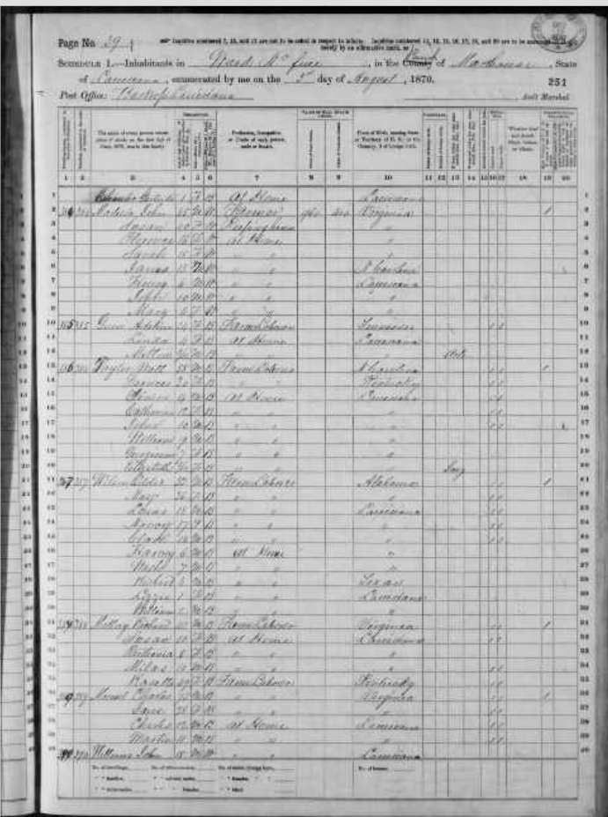
https://www.familysearch.org/ark:/61903/3:1:S3HY-68NK-WX?view=index&personArk=%2Fark%3A%2F61903%2F1%3A1%3AM877-Q8D&action=view&cc=1438024&lang=en&groupId=M9CF-G7Y
- Family of John and Susan Madison found in 1850 Census. This shows Henry Madison as a son, age 6 (see line 7).
(John/James Madison) Generation 5-6
“Death Claims H. Flood Madison,” Morehouse Enterprise (Morehouse, Louisiana), 7 May 1926; digital image, FamilySearch (FamilySearch.org : accessed 18 December 2025).
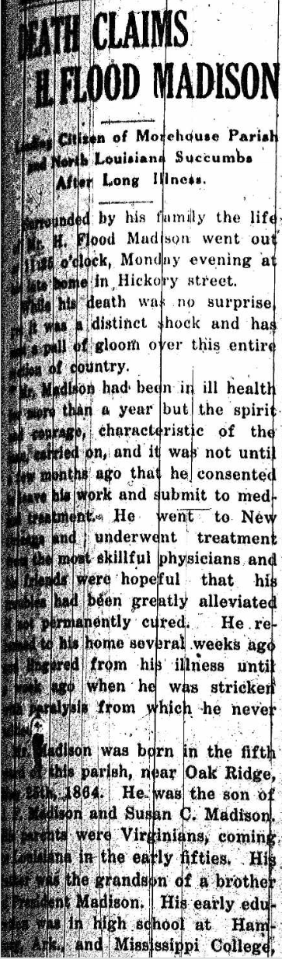
https://www.familysearch.org/en/tree/person/memories/LZK4-G2H
- This names President James Madison as Henry Flood Madison’s 3rd cousin and John Flood Madison as his father.
(Col. James Madison) For Generation 5 - 6
https://relativefinder.org/#/connect

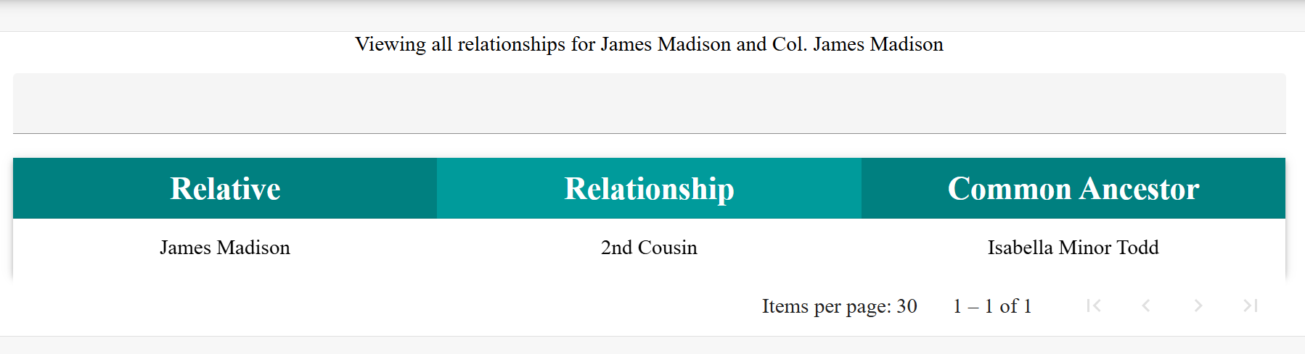

- Colonel James Madison is the 2nd cousin of James Madison, thus making John Flood Madison his son (Generation 4)
- John Flood Madison is not found listed in a census after 1850 with his parents.
- John Flood Madison (born in 1825), the older brother of the above-referenced Henry Flood Madison, is a “tick-mark” in the 1840 census, column males 10-under 14, possibly based on the month of birth and month of census. Once a male reached age 16, the head of household could be taxed a poll tax, depending on the jurisdiction's laws.

(John Flood Madison – Col. James Madison) Generations 5 – 6
“1830 U.S. Census for Prince Edward, Virginia, population schedule, p. 227; digital image, FamilySearch (FamilySearch.org : accessed 19 December 2025).

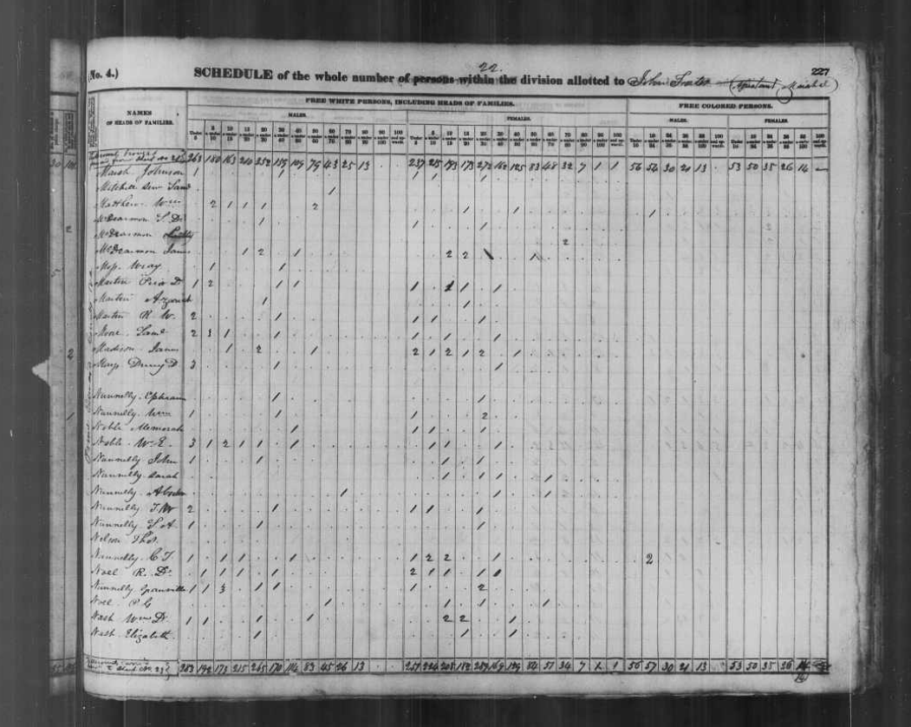
- John Flood Madison is the male child, aged 10 – 14, on this census record.

(Susan Edmunds) Marriage, Generation 6
“Marriage Register, 1751-1853, Brunswick County, Virginia,” digital image, FamilySearch (FamilySearch.org : accessed 18 December 2025); Film #007578837, image 325; entry for Susanna Edmunds and James Madison, 4 May 1813.
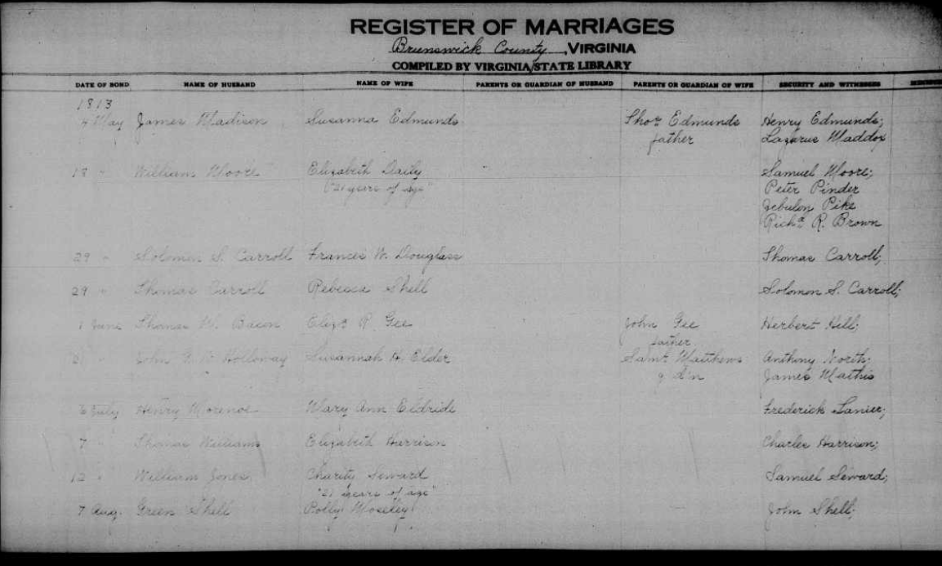
https://www.familysearch.org/ark:/61903/3:1:3QS7-89XL-X8YQ?view=explore&action=view&cc=4149585&lang=en&groupId=TH-1942-40244-9141-23
- Thomas Edmunds is named as father of Susanna; no parents are indicated for James.

(Susan Edmunds) Marriage, Generation 6
“Marriage Register, 1751-1853, Brunswick County, Virginia,” digital image, FamilySearch (FamilySearch.org : accessed 18 December 2025); Film #007578837, image 532; entry for Susanna Edmunds and James Madison, 6 May 1813.
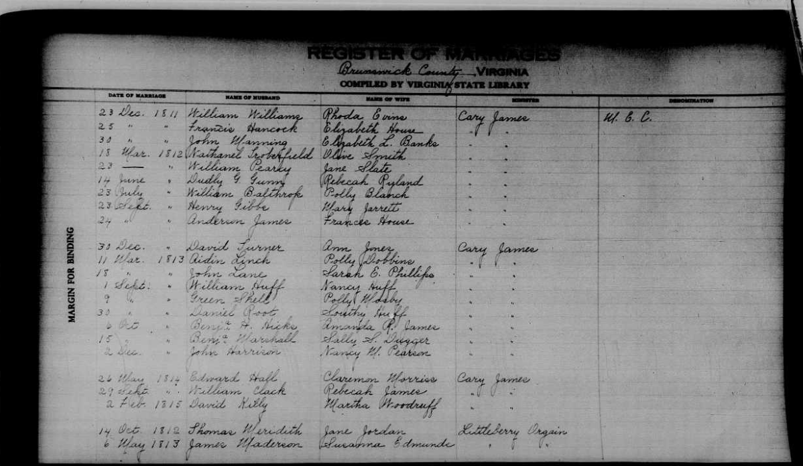
https://www.familysearch.org/ark:/61903/3:1:3QS7-L9XL-XD3H?view=explore&action=view&cc=4149585&lang=en&groupId=TH-1942-40244-9141-23
- Date of marriage is listed as 6 May 1813 for Susanna Edmunds and James.

(Susan Edmunds) Generation 6 - 7
“Virginia, U.S., Wills and Probate Records, 1652-1900,” digital image, Ancestry (Ancestry.com : accessed 18 December 2025); Will Book, Vol. 8-10, 1812-1828; entry for Thomas Edmunds, 24 Sep 1825 and 28 Nov 1825.
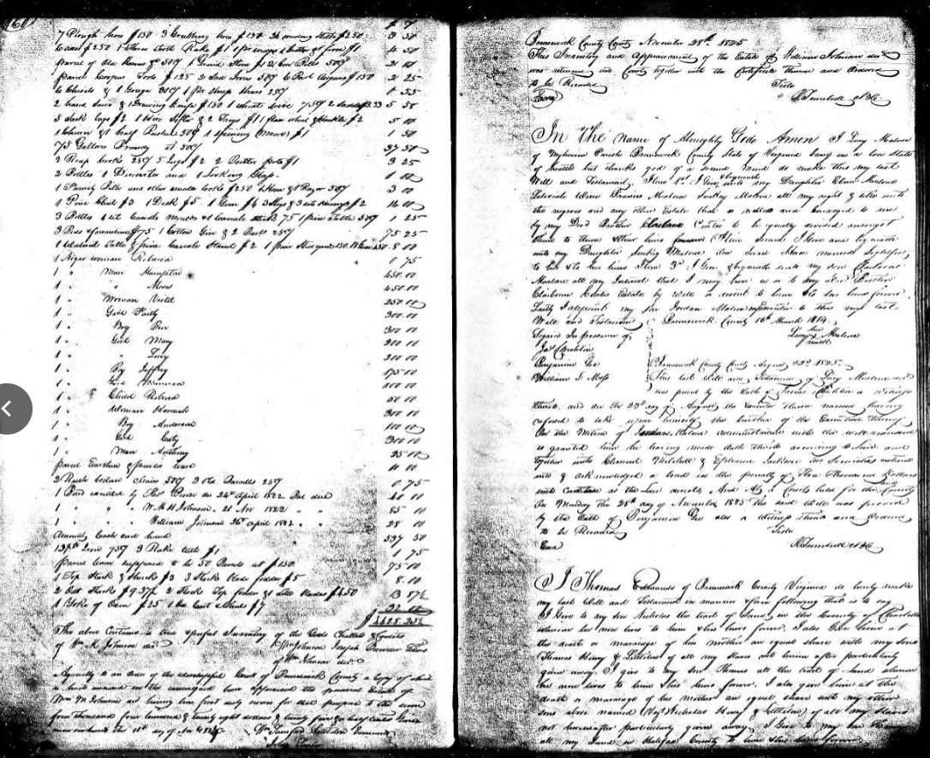
https://www.ancestry.com/search/collections/62347/records/1762722
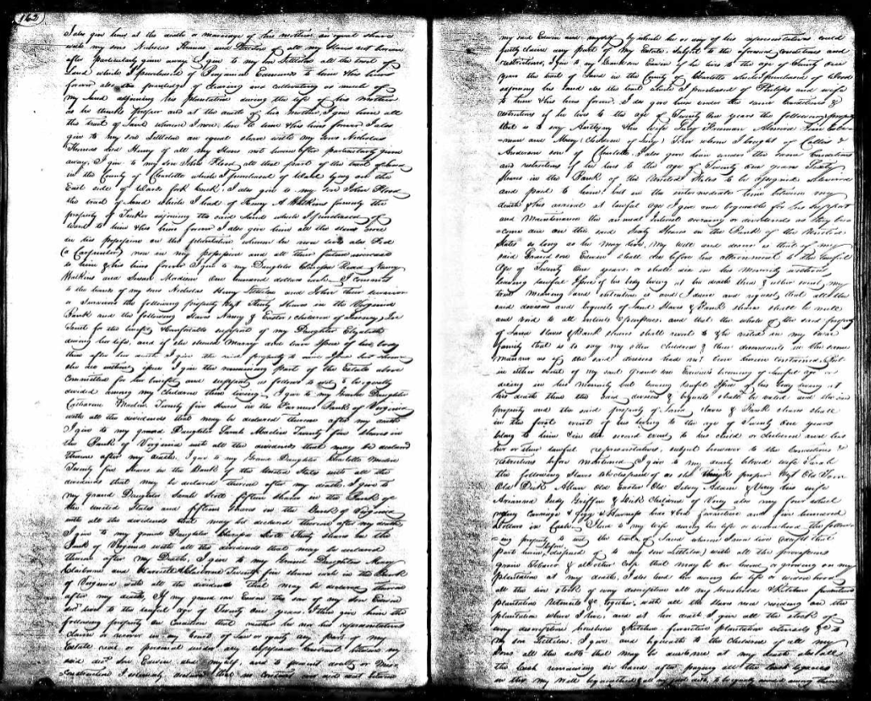
- Susan Madison is identified as Thomas Edmund’s daughter.
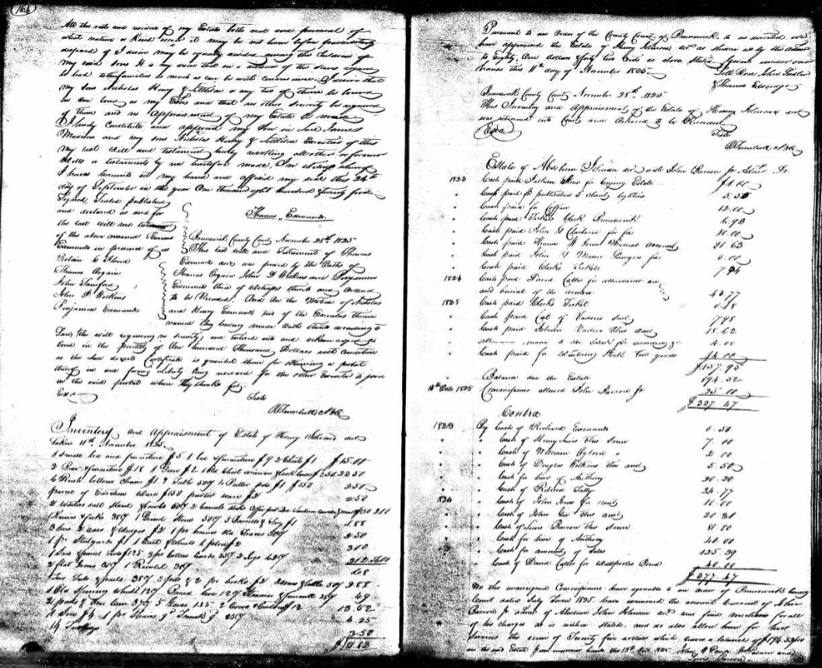

- James Madison is named as a son-in-law (husband to Susan) and an executor of Thomas Edmund’s will.

(Thomas Edmunds) Marriage, Generation 7
“Marriage Register, 1751-1853, Brunswick County, Virginia,” digital image, FamilySearch (FamilySearch.org : accessed 18 December 2025); Film #007578837; Image 144; entry for Thomas Edmunds and Sarah Eldridge, 25 November 1771.

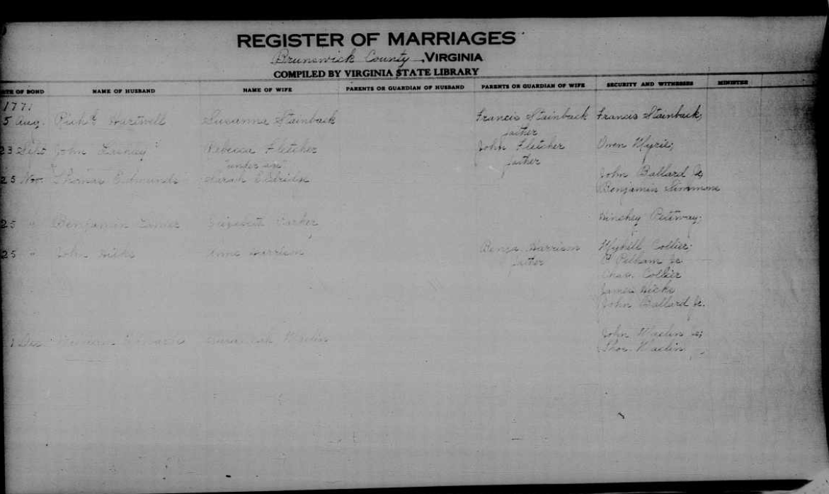

- Shows Thomas’s marriage to Sarah Eldridge, no parents are listed.

(Nicholas Edmunds) Generations 7 -8
“Will Book 5, 1778-1795, Brunswick County, Virginia,” digital image, FamilySearch (FamilySearch.org : accessed 19 December 2025); entry for Nicholas Edmunds, 25 May 1789.
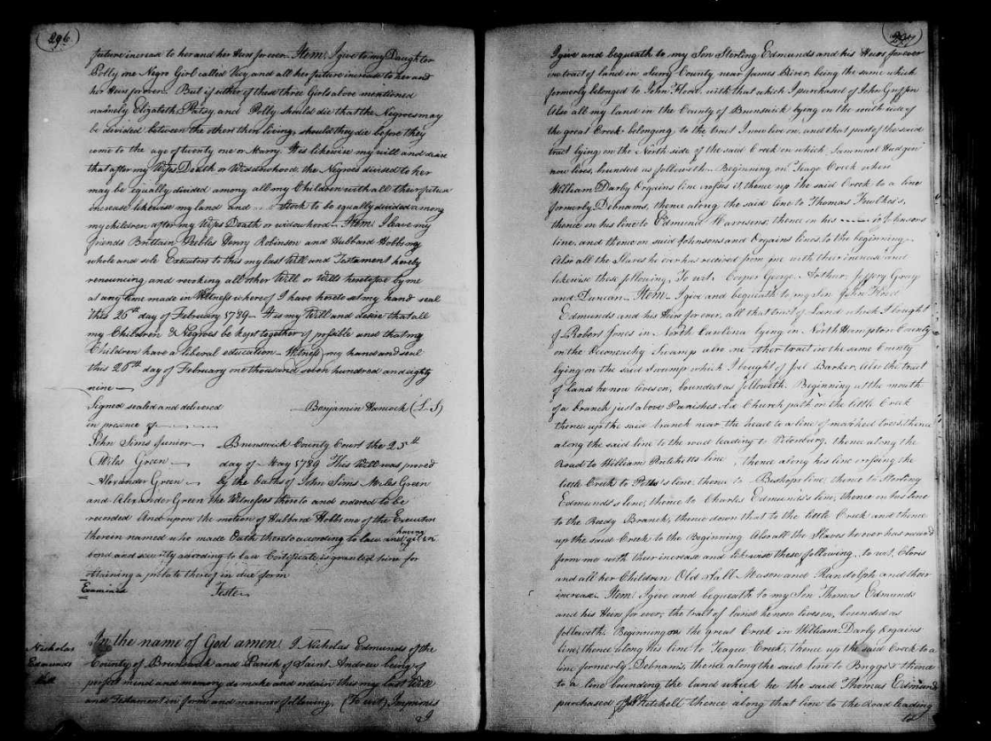

(Nicholas Edmunds) p.2
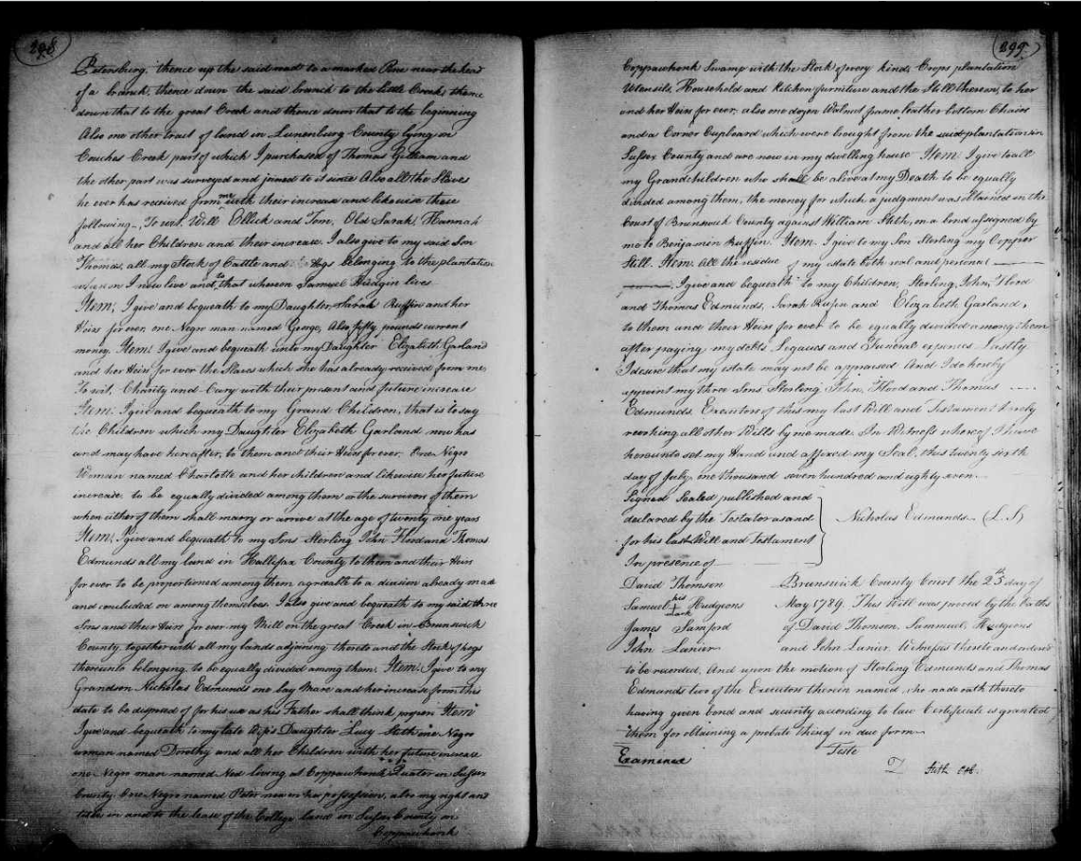
https://www.familysearch.org/ark:/61903/3:1:3QSQ-G9PH-SZ5H?view=explore&keywords=Thomas%20Edmunds%2Cprobate%2CSurry&lang=en&groupId=M9FB-VBQ
- This will by Nicholas Edmunds mentions Thomas Edmunds as his son.
- Indirect evidence of relation to the Flood line. Elizabeth had passed away by the date of this will. However, Nicholas gives his oldest son land that is his, formerly belonging to John Flood, along with land Nicholas had purchased from another, hinting that John Flood’s land was inherited.
- Nicholas names his three sons as Sterling, John Flood, and Thomas Edmunds, suggesting that his second son used his middle name as we would today use a hyphenated name, John-Flood. Flood was the maiden name of Elizabeth, the mother of these children, which also links Elizabeth to the family.
(Nicholas Edmunds/Elizabeth Flood) compiled lineage, document 1 Generation 8; 8 - 9
“United States, Compiled Genealogical Collections,” digital image, FamilySearch (FamilySearch.org : accessed 19 December 2025); entry for Nicholas Edmunds and Elizabeth Flood, about 1709.
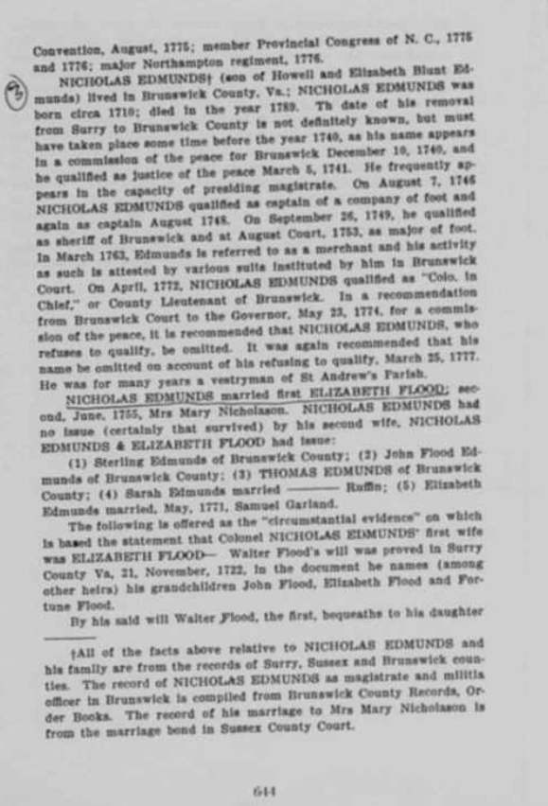
https://www.familysearch.org/ark:/61903/3:1:3QHV-B35C-XKYK?view=explore&keywords=Flood%2CTHOMAS%20EDMUNDS%2CELIZABETH%20FLOOD%2CElizabeth%20Flood%2CSurry&lang=en&groupId=TH-7774-102884-15091-47
- Nicholas and Elizabeth married about 1709 in Virginia. Elizabeth died before 1755, leaving Nicholas with five children.
- See the circumstantial evidence indicated in the above document regarding Elizabeth Flood being the daughter of Walter Flood (Jr.).
(Elizabeth Flood) compiled lineage, document 2 Generation 8; 8 – 9
“Southern District, Alaska, United States Records,” image, FamilySearch (FamilySearch.org : accessed 18 December 2025); entry for Elizabeth Flood, daughter of Walter Flood and Sarah (Simmons) and wife of Nicholas Edmunds.

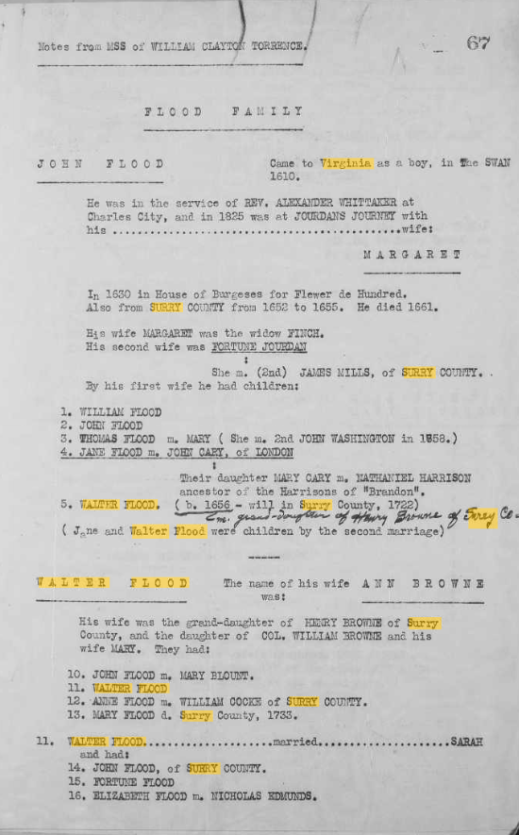
https://www.familysearch.org/ark:/61903/3:1:3QHK-Q3PV-D6Q1?view=explore&keywords=WALTER%20FLOOD%2CWalter%20Flood%2CVirginia%2CSURRY%2CSurry&lang=en&groupId=TH-7774-102252-10395-6
- Elizabeth was the daughter of Walter Flood (Jr.) and Sarah (Simmons). Elizabeth married Nicholas Edmunds.
(Walter Flood, Jr.) Marriage, Generation 9
“U.S. and International Marriage Records, 1560-1900,” database, Ancestry (Ancestry.com : accessed 19 December 2025); entry for Walter Flood and Sarah Simmons, 1705.
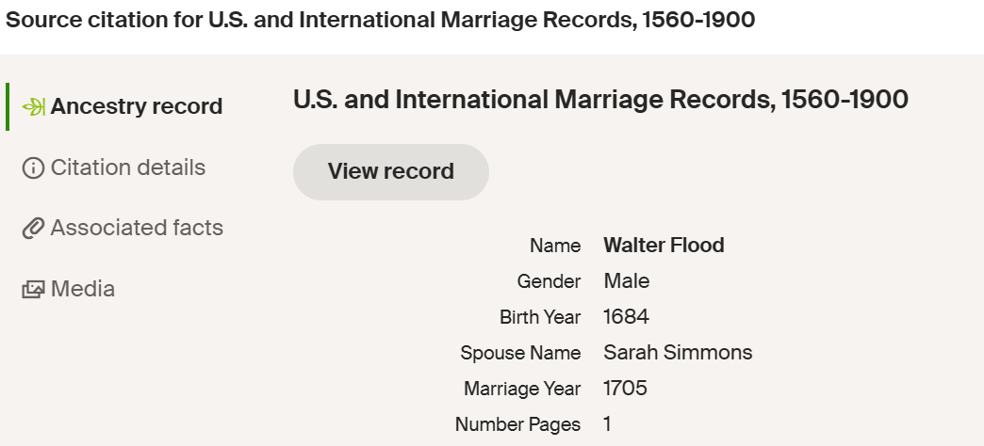
https://www.ancestry.com/family-tree/person/tree/187257243/person/432600336920/facts
- Record of marriage to Sarah Simmons, 1705.

(Walter Flood, Jr.) Generation 9
“Deeds, Wills, Etc. Part 2, 1715-1730, Surry County, Virginia,” digital image, FamilySearch (FamilySearch.org : accessed 18 December 2025); Film #007645823, Image 6; entry for Walter Flood Jr. and Sarah Flood, 16 February 1720.
https://www.familysearch.org/ark:/61903/3:1:3Q9M-C9PX-29FM-9?view=explore&keywords=William%20Phillips&lang=en&groupId=M9JJ-WYV
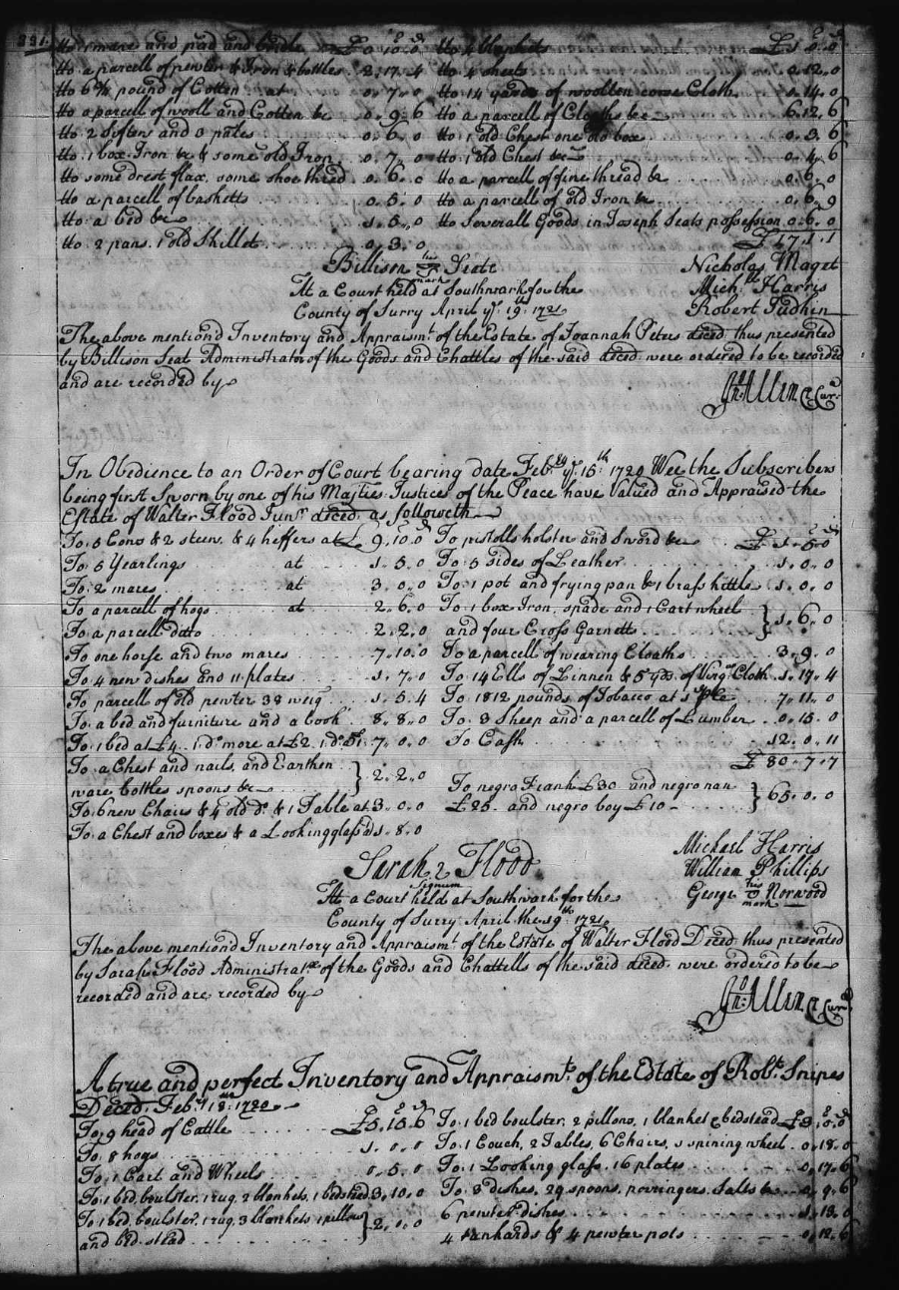
- Walter Flood, Jr. died intestate, leaving his wife, Sarah to be the administratrix of his goods.
(Walter Flood, Sr. – Walter Flood Jr.) Generations 9 - 10
“Wills and Deeds, Surry County, Virginia, 1652-1907,” digital image, FamilySearch (FamilySearch.org : accessed 19 December 2025); Film #007645823, image 327; entry for Walter Flood to Walter Flood, 15 February 1720.
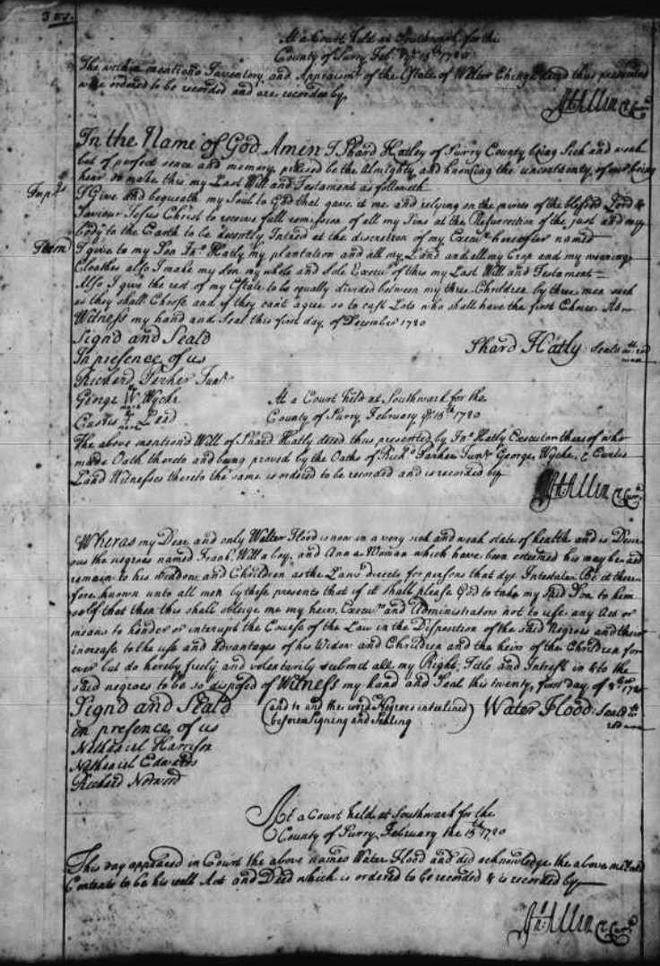
https://www.familysearch.org/ark:/61903/3:1:3Q9M-C9PX-2962-6?lang=en&i=326
- Walter Flood indicates that his son, Walter Flood, is very sick and desires to adjust his will in case his son dies.
- Walter Flood, Jr., did pass away before his father.

(Walter Flood, Sr.) Marriage, Generation 10
“U.S. and International Marriage Records, 1560-1900,” database, Ancestry (Ancestry.com : accessed 19 December 2025); entry for Walter Flood and Anne Browne, 1677.
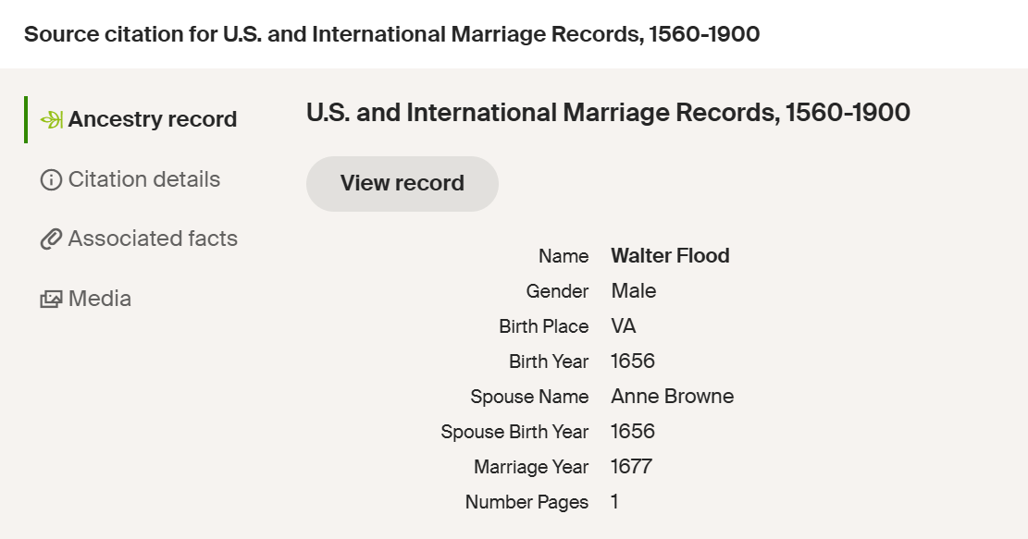
https://www.ancestry.com/search/collections/7836/records/417719?tid=205159507&pid=152688223116&ssrc=pt
- Record of Marriage for Walter Flood (Sr.) and Anne Browne in Virginia, 1677.
- Both Walter and Anne are recorded as being born in 1656.

(William Flood, Sr.) Generations 9 - 10
“Deeds and Wills Etc. 5, Part 2, 1694-1709, Surry County, Virginia,” digital image, FamilySearch (FamilySearch.org : accessed 19 December 2025); Film #0076645822, Image 84; entry for William Browne mentioning Ann Flood, the wife of Walter Flood, 3 July 1705.
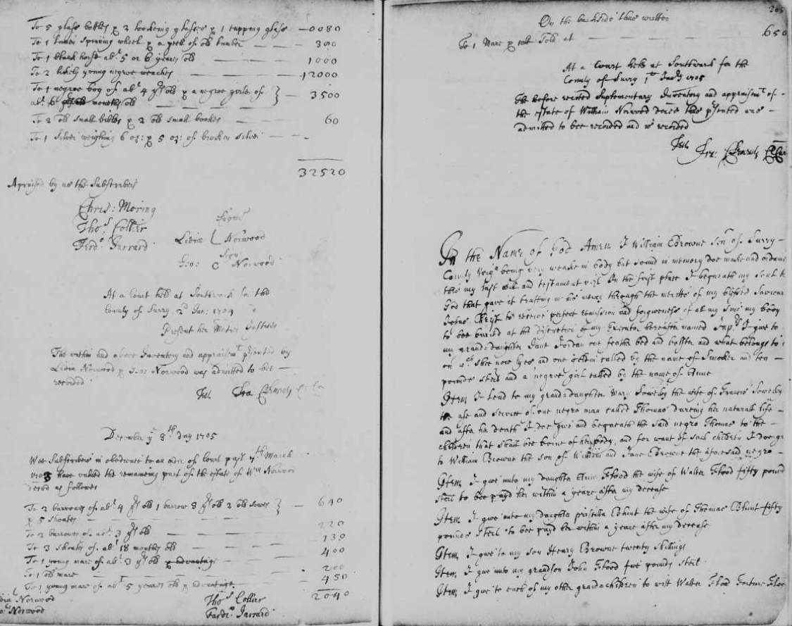

(Walter Flood, Sr.) p. 2 of the will of father in law, William Browne
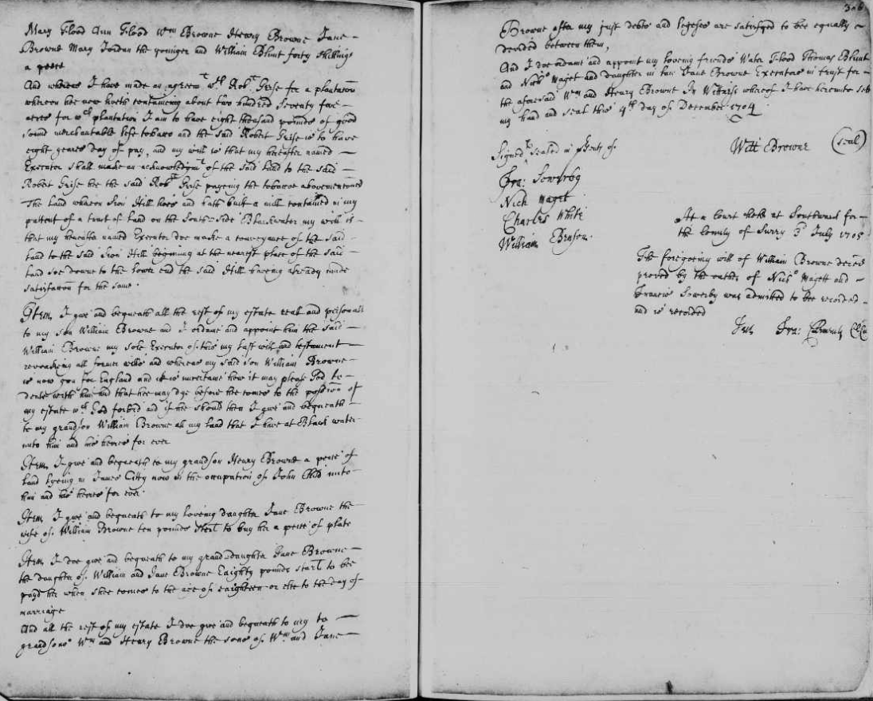
https://www.familysearch.org/ark:/61903/3:1:3Q9M-C9PX-V39K-D?view=explore&keywords=William%20Browne%2CFlood%20Ann%20Flood%2CSurry&lang=en&groupId=M9JJ-Z44
- Proves marriage between Walter Flood (Sr.) and Ann Browne.
- References daughter, Ann Flood, the wife of Walter Flood, again proving marriage of Walter Sr.
- William names Walter (Jr) as a grandson.

(John Flood) Generations 10 - 11
“Deeds and Wills, 1645-1672, Surry County, Virginia,” digital image, FamilySearch (FamilySearch.org : accessed 19 December 2025); Film #007645827, Image 216; entry for John Flood and Walter Flood, 16 December 1669.
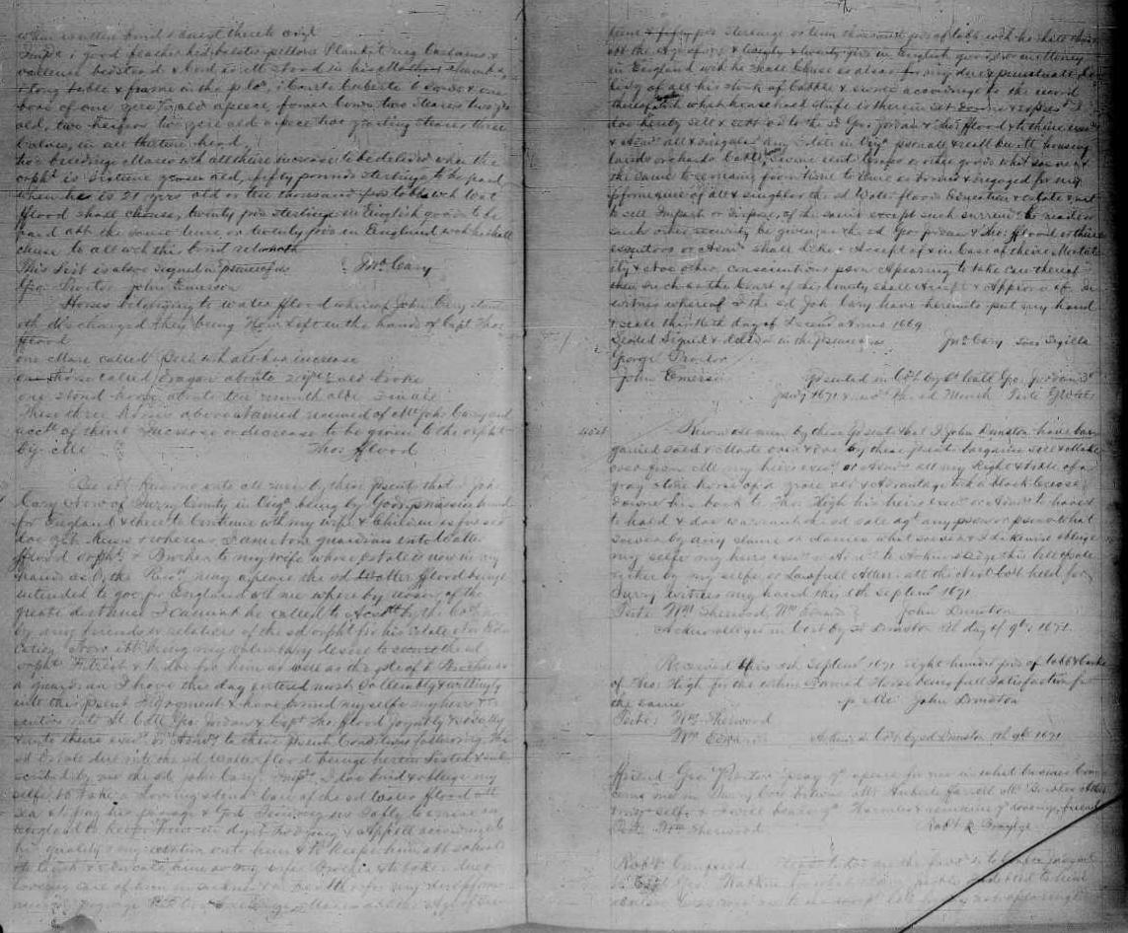
https://www.familysearch.org/ark:/61903/3:1:3Q9M-C9PX-GSLZ-1?view=explore&keywords=Jordan%2CGeo%2CWalter%20flood%2CSurry&lang=en&groupId=M9XQ-TQH
- This document states that John Cary is bound for England. He is now the guardian of Walter Flood, an orphan and brother of his wife, [Jane.] (John Cary was married to Jane Flood, daughter of John and Fortune (Jordan) Flood (Mills, Fortune’s married name after the death of John.) John Flood died on 14 November 1658. Fortune (Jordan) Flood Mills passed away on 14 July 1669.

