Transcription for an early 19th-century document

Citation:
“Virginia, U.S., Wills and Probate Records, 1652-1900,” digital image, Ancestry (https://www.ancestry.com/imageviewer/collections/62347/images/007644013_00605? : accessed 13 December 2025); citing Brunswick, Will Books, vol. 8 – 10, 1812-1828, p. 161-164; entry for Thomas Edmunds, 28 November 1825.

Original document, as follows: 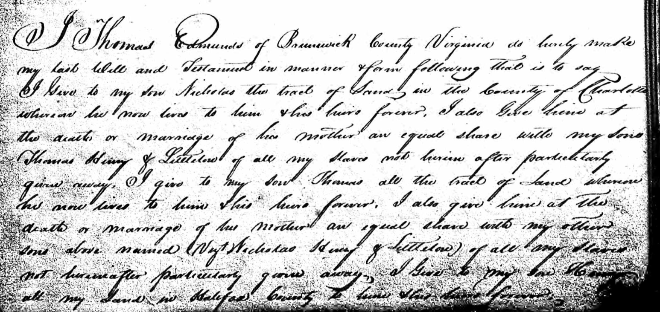

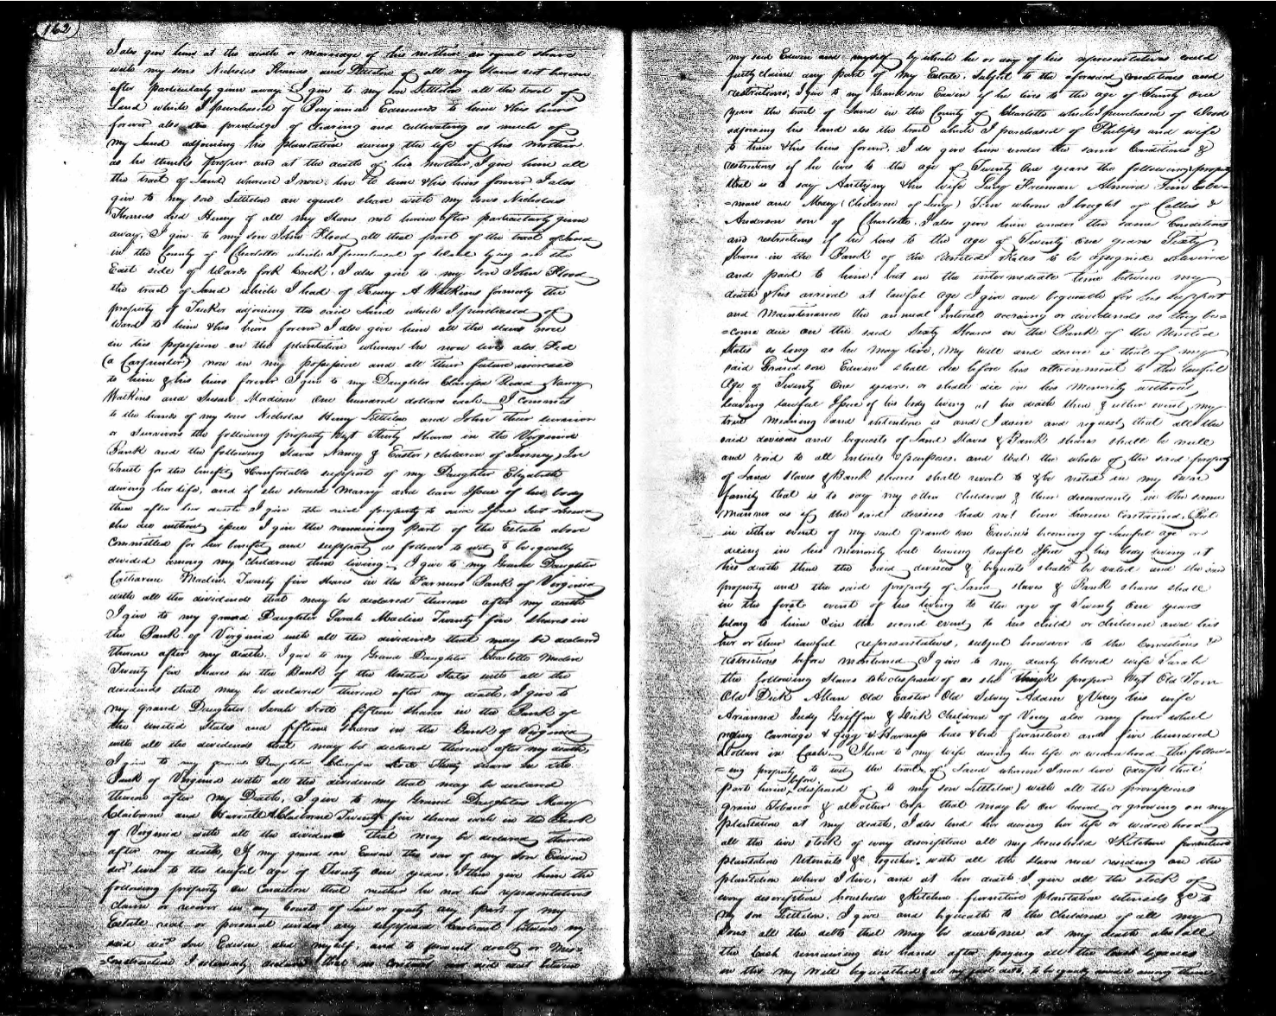
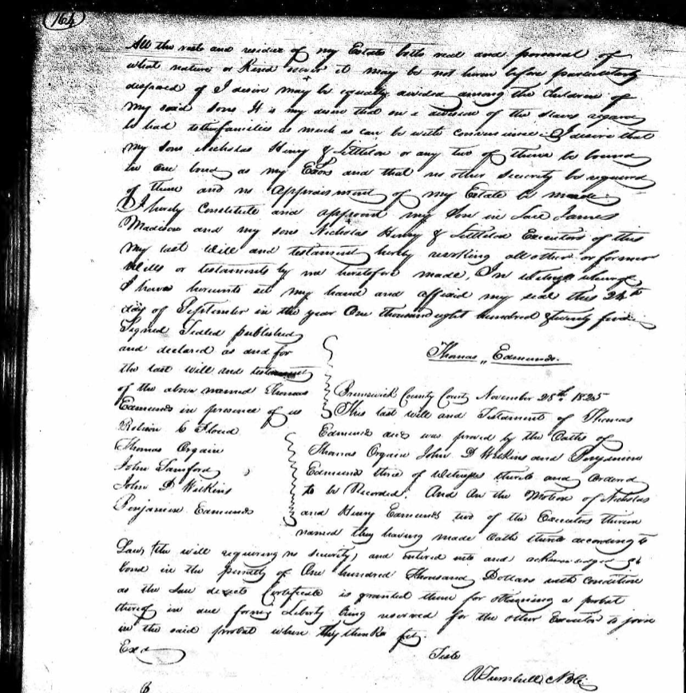

Transcription document, as follows:
p. 161 of Will Books, Vol. 8-10, 1812-1828, bottom of page:
- I Thomas Edmunds of Brunswick County Virginia do hereby make
- my last Will and Testament in manner & form following that is to say
- I Give to my son Nicholas the track of Land in the County of Charlotte
- werein he now lives to him & his heirs forever. I also Give him at
- the death or marriage of his mother an equal share with my Sons
- Thomas Henry of Littleton of all my Slaves not herein after particularly
- given away. I give to my son Thomas all the tract of Land whereas
- he now lives to him & his heirs forever. I also give him at the
- death or marriage of his mother an equal share with my other
- sons above named (Nayt Nicholas Henry of Littleon) of all my slaves
- not hereinafter particularly given away. I Give to my son Henry
- all my Land in Halifax County to him & his heirs forever.
p. 162 of Will Books, Vol. 8-10, 1812-1828:
1. I also give him at the death or marriage of his mother, an equal share
2. with my sons Nicholas Thomas and Littleton of all my slaves not herein
3. after particularly given away. I give to my Son Littleton all the tract of
4. Land which I purchased of Benjamin Edmunds to him & his heirs
5. forever also the privilege of clearing and cultivating as much of
6. my Land adjoining his plantation during the life of his mother
7. as he thinks proper and at the death of his mother, I give him all
8. the tract of Land whereon I now live to him & his heirs forever. I also
9. give to my son Littleton an equal share with my sons Nicholas
10. Thomas and Henry of all my slaves not herein after particularly given
11. away, I give to my son John Flood, all that part of the tract of Land,
12. in the County of Charlotte which I purchased of Blard lying on the
13. East side of Blairs Fork & neck. I also give to my son John Flood,
14. the tract of Land which I had of Henry A. Watkins formerly the
15. property of Tucker adjoining the said Land which I purchased of
p. 162 of Will Books, Vol. 8-10, 1812-1828 (cont’d):

16. Ward to him & his heirs forever. I also give him all the slaves now
17. in his possession on the plantation where on he now lives also Joe
18.(a carpenter) now in my possession and all their future increase
19. to him & his heirs forever. I give to my Daughters Clarissa Road, Nancy
20. Watkins and Susan Madison one hundred dollars each. I commit
21. to the hands of my sons Nicholas Henry Littleton and John their succesion
22. or survivors the following property. Next Thirty shares in the Virginia
23. Bank and the following Slaves Nancy of Easter, children of Jinney, Joe
24. Faust for the benefit & comfortable support of my Daughter Elizabeth
25. during her life, and if she should marry and have issue of her body
26. them after her death. I give the said property to said issue but should
27. she die without issue I give the remaining part of the Estate above
28. committed for her benefit and support as follows to with to be equally
29. divided among my children then living. I give to my Grand Daughter
30. Catharine Madison Twenty five shares in the Farmers Bank of Virginia
31. with all the dividends that may be declared thereon after my death.
32. I give to my grand Daughter Sarah Madison Twenty five shares in
33. the Bank of Virginia with all the dividends that may be acclaimed
34. after my death. I give to my Grand Daughter Charlotte Madison
35. Twenty five Shares in the Bank of the United States with all the
36. dividends that may be declared thereon after my death. I give to
37. my grand Daughter Sarah Scott fifteen shares in the Bank of
38. the United States and fifteen shares in the Bank of Virginia
39. with all the dividends that may be declared thereon after my death.
40. I give to my grand Daughter Clarissa Scott Thirty shares in the
41. Bank of Virginia with all the dividends that may be declared
42. thereon after my Death. I give to my Grand Daughter Mary
43. Claiborne and Harriett A. Claiborne Twenty five shares each in the Bank
44. of Virginia with all the dividends that may be declared thereon
p. 162 of Will Books, Vol. 8-10, 1812-1828 (cont’d):

45. after my death. If my grand son Edwin the son of my Son Edwin
46. dec[ease]d lives to the lawful age of Twenty one years, I then give him the
47. following property on condition that neither he nor his representatives
48. claim or recover in any Court of Law or equity any part of my
49. Estate real or personal under any superseded Contract between my
50. said dec[ease]d Son, Edwin and myself, and to forward death or mis=
51. constructive, I solemnly declare that no contracts did [ineligible word] between

p. 163 of Will Books, Vol. 8-10, 1812-1828:
1. my son Edwin and myself by which he or any of his representatives could
2. justly claim any part of my Estate, Subject to the aforesaid conditions and
3. restrictions; I give to my Grandson Edwin if he lives to the age of Twenty one
4. years the tract of land in the County of Charlotte which I purchased of Wood
5. adjoining his land also the tract which I purchased of Philips and wife
6. to him & his heirs forever. I do give him under the same Conditions &
7. restrictions if he lives to the age of Twenty One years the following property
8. that is to say Anthony & his wife Lucy Freeman Almira & Joe Cole=
9. man and Mary (children of Lucy) Son whom I bought of Collis &
10. Anderson son of Charlotte, I also give him under the same conditions
11. and restrictions if he lives to the age of Twenty One years, sixty
12. shares in the Bank of the United States to be assigned delivered
13. and paid to him, but in the intermediate time between my
14. death & his arrival of lawful age I give and bequeath for this support
15. and maintenance the annual interest accruing or dividends as they be=
16. come due on this said Sixty shares in the Bank of the United
17. States as long as he may live. My will and desire is that if my
18. said grandson Edwin shall die before his attainment to the lawful
19. age of Twenty One years, or shall die in his minority without
20. leaving lawful issue of his body living at his death then if either event, my
p. 163 of Will Books, Vol. 8-10, 1812-1828 (cont’d):
21. true meaning and intention is and I desire and request, that all the
22. said divisions and bequests of land, Slaves & Bank shares shall be null
23. and void to all intents & purposes and that the whole of the said property
24. of Land, Slaves & Bank shares shall revert to & be vested in my sons
25. family that is to say my other children & their descendants in the same
26. manner as if the said devices had not been herein contained. But
27. in either event if my said grandson Edwins becoming of lawful age or
28. dieing in his minority but leaving lawful issue of his body living at
29. his death these the said, desires & bequests shall be valid and the said
30. property and their said prosperity of land, slaves & Bank shares shall
31. belong to him & in the second event, to his child or children and his
32. heir or their lawful representatives, subject however to the conditions &
33. restrictions before mentioned. I give to my dearly beloved wife Sarah
34. the following Slaves to be disposed of as she thinks proper. Vazt Old Tom
35. Old Dick Allan Old Easter Old Lewey Adam & Vicey his wife
36. Arianna Judy Griffin & Dick children of Vicey also my four wheel
37. riding carriage & gigg- & Harness beds & bed furniture and five hundred
38. dollars in cash. I lend to my wife during her life or widowhood, the follow=
39. ing property to with the tract of Land whereon I now live (except that
40. part herein before disposed of to my son Littleton) with all the provisions
41. grain tobacco & other crops that may be on hand, or growing on my
42. plantation at my death. I also lend her during her life or widowhood,
43. all the live stock of every description all my household & kitchen furniture
44. plantation utensils etc. together with all the slaves now residing on the
45. plantation where I live, and at her death I give all the stock of
46. every description household & kitchen furniture plantation utensils etc. to
47. my son Littleton. I give and bequeath to the children of all my
48. Sons all the debts – that may be due to my death also all
49. the cash remaining on hand after paying all the cash legacies
50. in this my will bequeathed & all my parts doeth, to be equally divided among themselves
p. 164 of Will Books, Vol. 8-10, 1812-1828:

- All the rest and residue of my Estate both real and personal of
- what nature or kind {?] etc. may be not herein before particularly
- disposed of I desire may be equally divided among the children of
- my said sons. It is my desire that on & division of the slaves regard,
- to had to their families as much as can be with conscious desire. I desire that
- my sons Nicholas Henry & Littleton or any two of them to bound
- to one land as my Ex[ecut]ors and that no other security be required
- of them and no appraisement of my Estate be made
- I hereby constitute and appoint my son in law James
- Madison and my sons Nicholas Henry & Littleton Executors of this
- my last will and testament by me heretofore made, In witness wereof
- I have hereunto set my hand and affixed my seal this 24th
- day of September in the year One thousand eight hundred twenty five.

Signed Sealed published
and declared as deed for Thomas Edmunds
the last will and testament
of the above named Thomas Brunswick County Court, November 28th 1825
Edmunds in presence of us This last will and Testament of Thomas
Robison C. Floud Edmunds dec[eased] was proved by the Oaths of
Thomas Orgain Thomas Orgain John D. Wilkins and Benjamin
John Larsford Edmunds terce of Witnesss thereto and ordered
John D. Watkins to be Recorded. And on the Motion of Nicholas
Benjamin Edmunds and Henry Edmunds, two of the Executors therein
named they having made oath claimed according to
Law, the will requiring no security, and entered into and acknowledged of
bond in the penalty of one hundred thousand dollars with conditions
as the law dictates. Certificate is granted them for obtaining a probate
thereof in due form Liberty being reserved for the other Executors to join
in the said probate when they think fit.
Scribe
R Tumbull [possibly NBle]

